Polytechnic Sector

FORMAT –“A”
Abstract of works projects physically completed under UT Capex Budget, Loan, Loan, CSS& PMDP during 2021-22
(Rs. In lakh)
Sr. No. | Source of funds | Total No. of works Physically completed during 2021-22 | Total AA cost | Total cost of completion/ expenditure
 | Capex Regular | 22 | 643.97 | 536.99
 | Loan Schemes | 0 | 0 | 0
 | CSS | 0 | 0 | 0
 | PMDP/Others | 0 | 0 | 0
 | Total: | 22 | 643.97 | 536.99

Format – “C”
Geo tagged Photographs of the work (JPG Format with details)

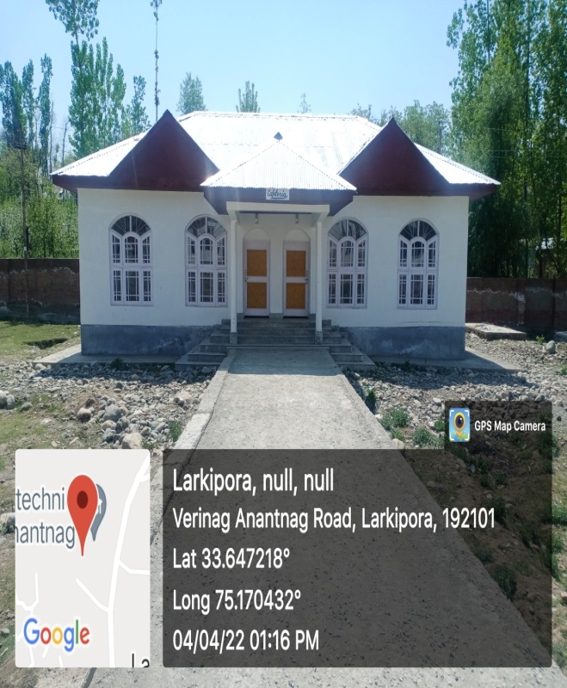 | Sr. No. | 01
 | Name of the  Work with location | Const of Cafeteria at Govt Polytechnic Anantnag
 | Department//  Organisation | Skill Development Department (Directorate of Skill Development)
 | Executing Agency | PWD (R&B)
 | Block/District | Anantnag
 | AA Cost (Rs. In lakh) | 38.66
 | Total cost of completion / Expdt incurred ending 3/2022 | 37.74
 | Date of start (Month/year) | Mar-19
 | Date of completion (Month/year) | Dec-21
 | No. of beneficiary | 01 (GP Anantnag)

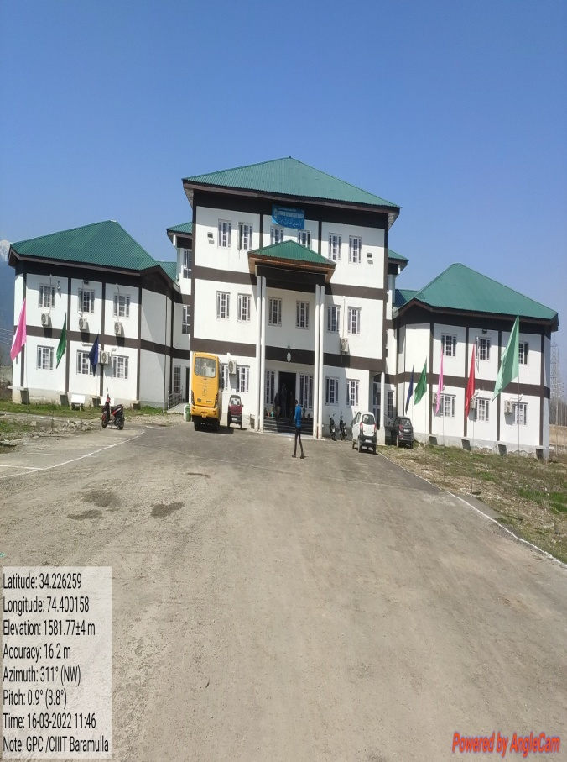 | Sr. No. | 02
 | Name of the  Work with location | Establishment of CIIIT at Govt. Polytechnic Baramulla
 | Department//  Organisation | Skill Development Department (Directorate of Skill Development)
 | Executing Agency | PWD (R&B)
 | Block/District | Baramulla
 | AA Cost (Rs. In lakh) | 405.36
 | Total cost of completion / Expdt incurred ending 3/2022 | 398.82
 | Date of start (Month/year) | Mar-20
 | Date of completion (Month/year) | Oct-21
 | No. of beneficiary | 350

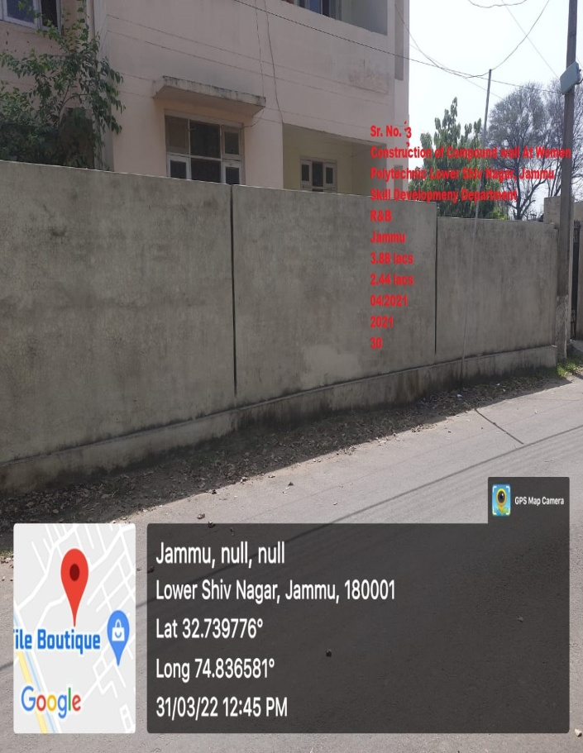 | Sr. No. | 03
 | Name of the  Work with location | Construction of compound walling for residential premises of GP Women Jammu
 | Department//  Organisation | Skill Development Department (Directorate of Skill Development)
 | Executing Agency | PWD (R&B)
 | Block/District | Jammu
 | AA Cost (Rs. In lakh) | 3.38
 | Total cost of completion / Expdt incurred ending 3/2022 | 2.44
 | Date of start (Month/year) | Apr-21
 | Date of completion (Month/year) | Dec-21
 | No. of beneficiary | 30

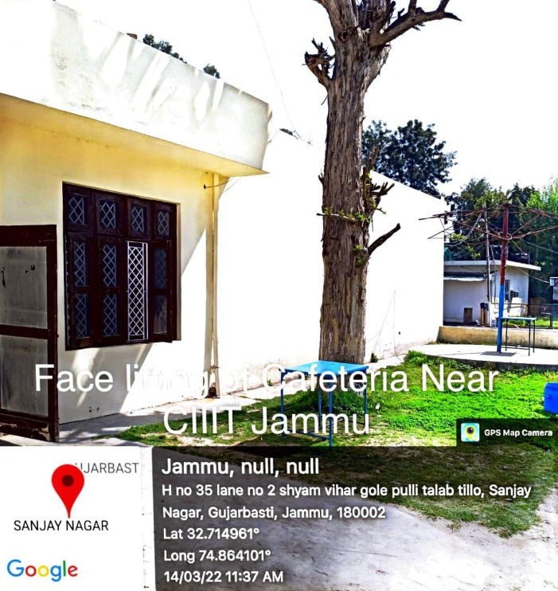 | Sr. No. | 04
 | Name of the  Work with location | Facelifting of Cafeteria near CIIIT, Jammu
 | Department//  Organisation | Skill Development Department (Directorate of Skill Development)
 | Executing Agency | PWD (R&B)
 | Block/District | Jammu
 | AA Cost (Rs. In lakh) | 4.00
 | Total cost of completion / Expdt incurred ending 3/2022 | 0.89
 | Date of start (Month/year) | Apr-21
 | Date of completion (Month/year) | Aug-21
 | No. of beneficiary | 500

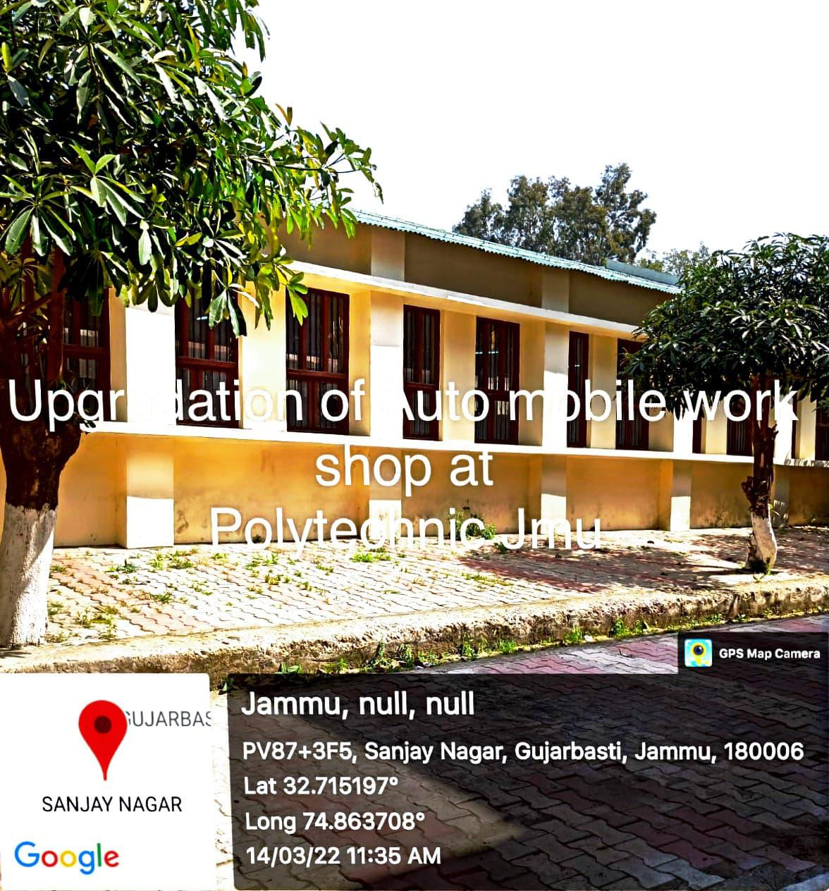 | Sr. No. | 05
 | Name of the  Work with location | Facelifting of Automobile Workshop near CIIIT, Jammu
 | Department//  Organisation | Skill Development Department (Directorate of Skill Development)
 | Executing Agency | PWD (R&B)
 | Block/District | Jammu
 | AA Cost (Rs. In lakh) | 2.68
 | Total cost of completion / Expdt incurred ending 3/2022 | 0.00 (Expdt made by the executing agency from its own resources)
 | Date of start (Month/year) | Mar-21
 | Date of completion (Month/year) | Aug-21
 | No. of beneficiary | 500

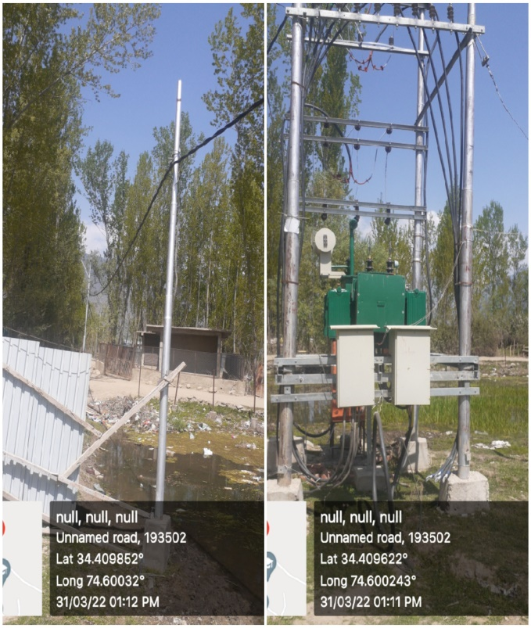 | Sr. No. | 06
 | Name of the  Work with location | Construction of 11 KVA Line at Govt. Polytechnic Bandipora
 | Department//  Organisation | Skill Development Department (Directorate of Skill Development)
 | Executing Agency | KPDCL (JKPDD)
 | Block/District | Bandipore
 | AA Cost (Rs. In lakh) | 12.60
 | Total cost of completion / Expdt incurred ending 3/2022 | 9.45
 | Date of start (Month/year) | Aug-21
 | Date of completion (Month/year) | Dec-21
 | No. of beneficiary | 310

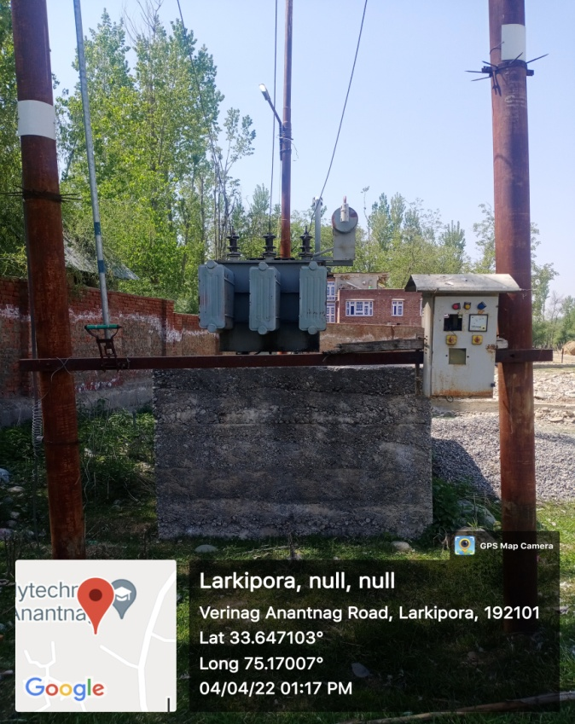 | Sr. No. | 07
 | Name of the  Work with location | 11KVA Power Supply to Govt. Polytechnic Larkipora Anantnag.
 | Department//  Organisation | Skill Development Department (Directorate of Skill Development)
 | Executing Agency | KPDCL (JKPDD)
 | Block/District | Anantnag
 | AA Cost (Rs. In lakh) | 10.89
 | Total cost of completion / Expdt incurred ending 3/2022 | 0.00 (Expdt made by the executing agency from its own resources)
 | Date of start (Month/year) | Aug-21
 | Date of completion (Month/year) | Feb-22
 | No. of beneficiary | 01 (GP Anantnag)

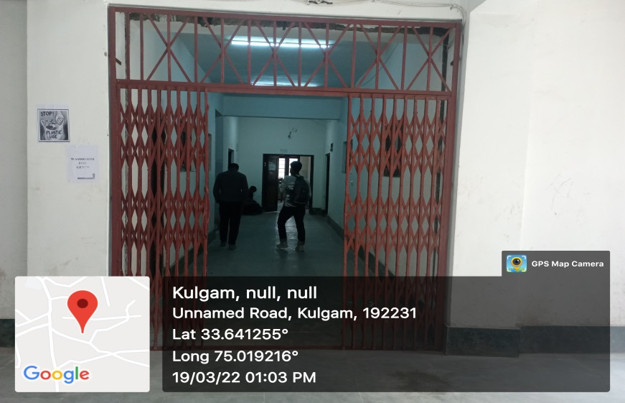 | Sr. No. | 08
 | Name of the  Work with location | Installation of 04 No. Collapsible Doors at Govt. Polytechnic Kulgam.
 | Department//  Organisation | Skill Development Department (Directorate of Skill Development)
 | Executing Agency | PWD (R&B)
 | Block/District | Kulgam
 | AA Cost (Rs. In lakh) | 4.00
 | Total cost of completion / Expdt incurred ending 3/2022 | 2.60
 | Date of start (Month/year) | Jun-21
 | Date of completion (Month/year) | Jun-21
 | No. of beneficiary | 01 (GP Kulgam)

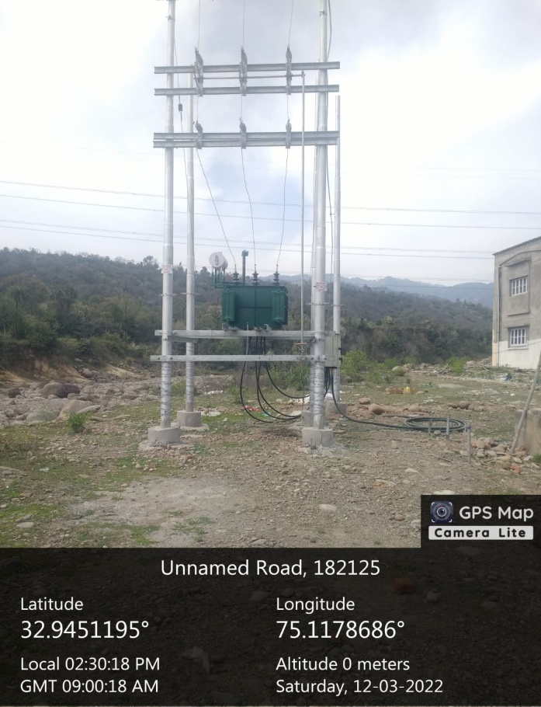 | Sr. No. | 09
 | Name of the  Work with location | Creation of 250 KvA Distribution SubStation at Govt Polytechnic Udhampur
 | Department//  Organisation | Skill Development Department (Directorate of Skill Development)
 | Executing Agency | JPDCL (JKPDD)
 | Block/District | Udhampur
 | AA Cost (Rs. In lakh) | 30.99
 | Total cost of completion / Expdt incurred ending 3/2022 | 7.05
 | Date of start (Month/year) | Jul-21
 | Date of completion (Month/year) | Jan-22
 | No. of beneficiary | 300

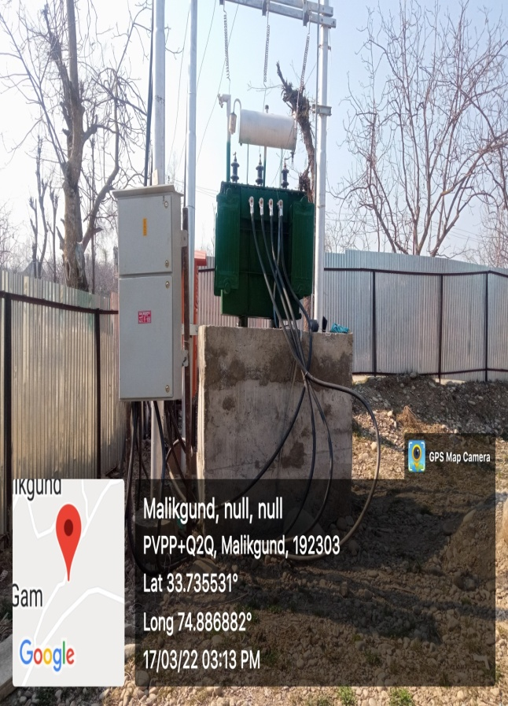 | Sr. No. | 10
 | Name of the  Work with location | Installation of 400 KvA Sub station along with HT LT Network for Govt Polytechnic Shopian
 | Department//  Organisation | Skill Development Department (Directorate of Skill Development)
 | Executing Agency | KPDCL (JKPDD)
 | Block/District | Shopian
 | AA Cost (Rs. In lakh) | 12.24
 | Total cost of completion / Expdt incurred ending 3/2022 | 9.18
 | Date of start (Month/year) | Jun-21
 | Date of completion (Month/year) | Mar-22
 | No. of beneficiary | 500

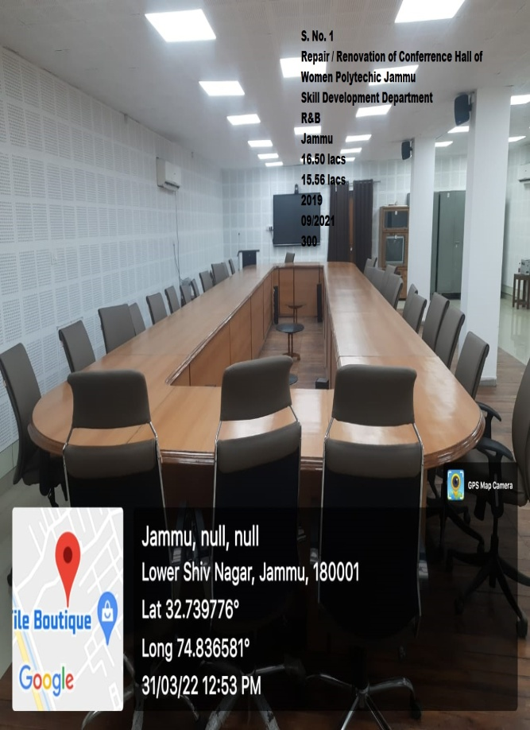 | Sr. No. | 11
 | Name of the  Work with location | Repair/Renovation of Conference Hall of Women Polytechnic Jammu.
 | Department//  Organisation | Skill Development Department (Directorate of Skill Development)
 | Executing Agency | PWD (R&B)
 | Block/District | Jammu
 | AA Cost (Rs. In lakh) | 16.53
 | Total cost of completion / Expdt incurred ending 3/2022 | 15.45
 | Date of start (Month/year) | Jun-19
 | Date of completion (Month/year) | Sep-21
 | No. of beneficiary | 300
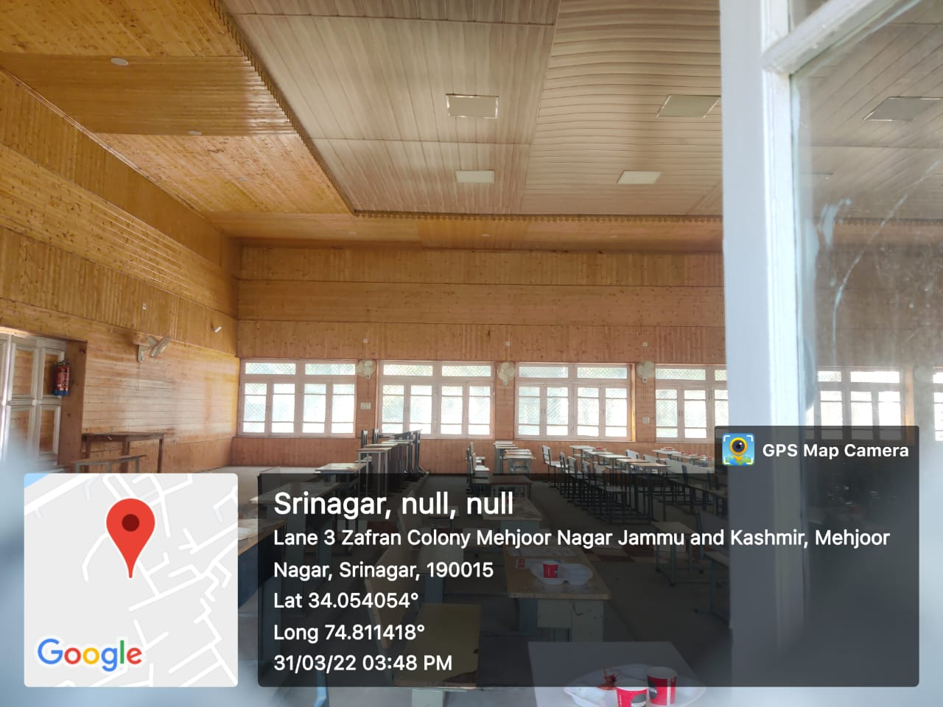 | Sr. No. | 12
 | Name of the  Work with location | Civil Work of Auditorium at KGP Srinagar including painting/ polishing at Kashmir Govt Polytechnic.
 | Department//  Organisation | Skill Development Department (Directorate of Skill Development)
 | Executing Agency | PWD (R&B)
 | Block/District | Srinagar
 | AA Cost (Rs. In lakh) | 10.35
 | Total cost of completion / Expdt incurred ending 3/2022 | 1.53
 | Date of start (Month/year) | Jun-20
 | Date of completion (Month/year) | Mar-22
 | No. of beneficiary | 1000

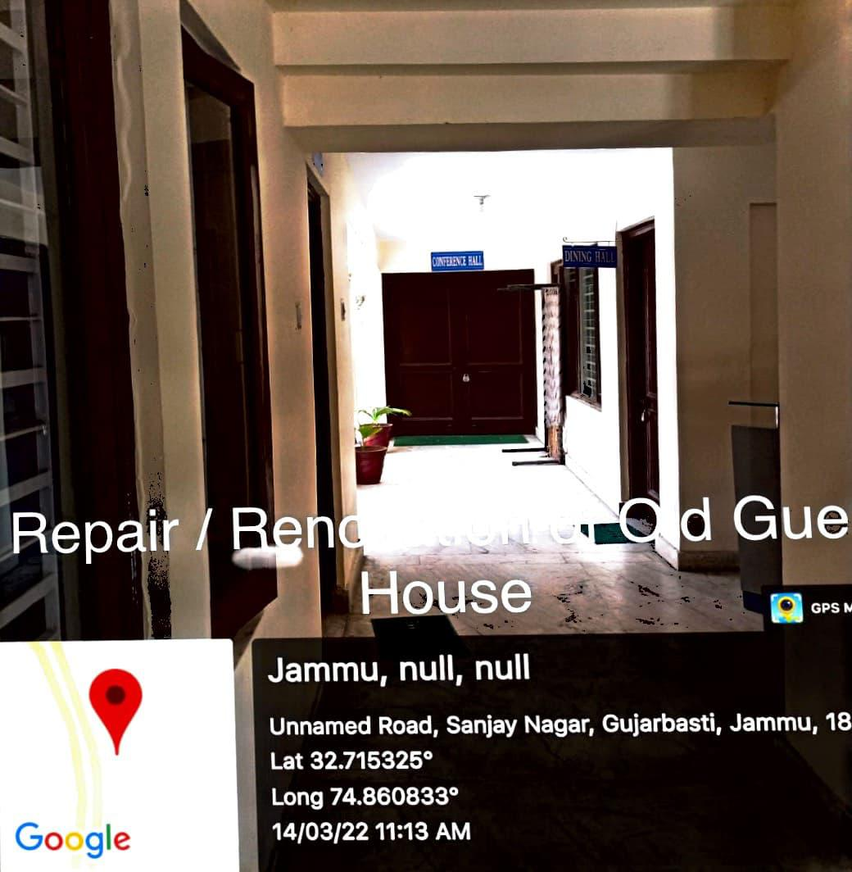 | Sr. No. | 13
 | Name of the  Work with location | Repair /Renovation of old Guest House at Govt. Polytechnic Boys Jammu
 | Department//  Organisation | Skill Development Department (Directorate of Skill Development)
 | Executing Agency | PWD (R&B)
 | Block/District | Jammu
 | AA Cost (Rs. In lakh) | 6.70
 | Total cost of completion / Expdt incurred ending 3/2022 | 4.26
 | Date of start (Month/year) | Mar-21
 | Date of completion (Month/year) | Aug-21
 | No. of beneficiary | 20

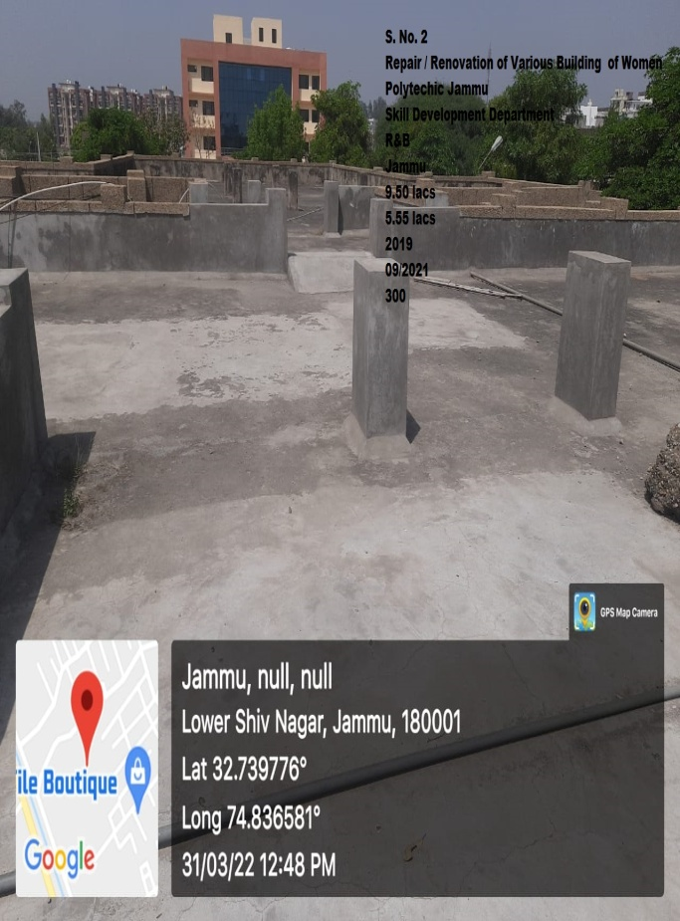 | Sr. No. | 14
 | Name of the  Work with location | Repair /Renovation of various buildings at Govt. women Polytechnic Jammu
 | Department//  Organisation | Skill Development Department (Directorate of Skill Development)
 | Executing Agency | PWD (R&B)
 | Block/District | Jammu
 | AA Cost (Rs. In lakh) | 7.17
 | Total cost of completion / Expdt incurred ending 3/2022 | 5.55
 | Date of start (Month/year) | Mar-21
 | Date of completion (Month/year) | Sep-21
 | No. of beneficiary | 300

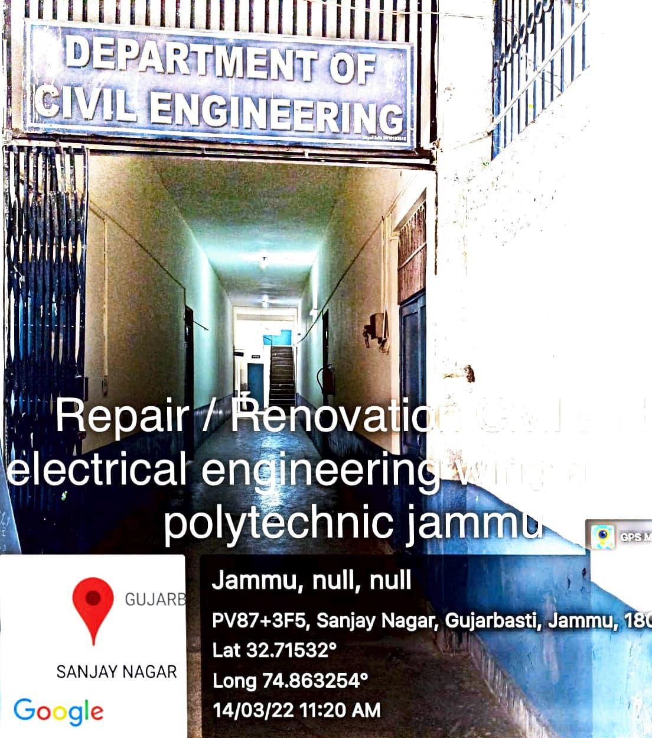 | Sr. No. | 15
 | Name of the  Work with location | Repair / Renovation of Civil & Electrical Engg. Wing at Govt Polytechnic Jammu
 | Department//  Organisation | Skill Development Department (Directorate of Skill Development)
 | Executing Agency | PWD (R&B)
 | Block/District | Jammu
 | AA Cost (Rs. In lakh) | 10.00
 | Total cost of completion / Expdt incurred ending 3/2022 | 4.18
 | Date of start (Month/year) | Jul-21
 | Date of completion (Month/year) | Oct-21
 | No. of beneficiary | 1000

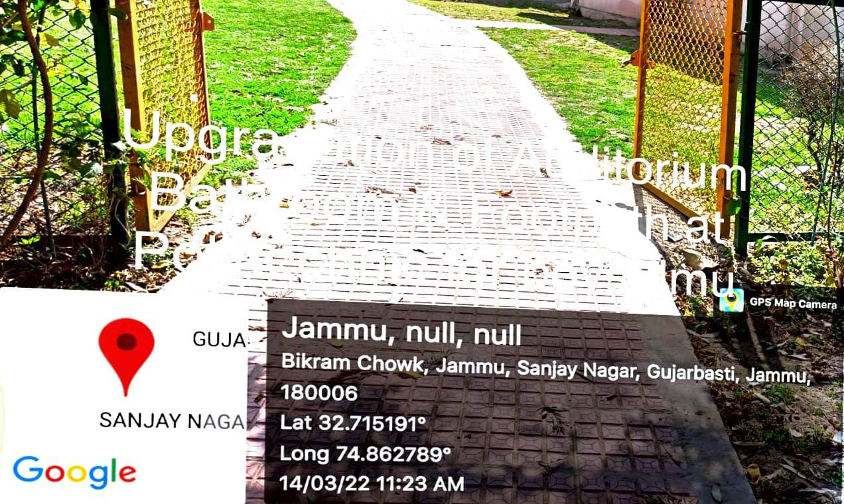 | Sr. No. | 16
 | Name of the  Work with location | Repair / Renovation of Auditorium Bathroom at Govt Polytechnic Jammu
 | Department//  Organisation | Skill Development Department (Directorate of Skill Development)
 | Executing Agency | PWD (R&B)
 | Block/District | Jammu
 | AA Cost (Rs. In lakh) | 7.00
 | Total cost of completion / Expdt incurred ending 3/2022 | 3.17
 | Date of start (Month/year) | Aug-21
 | Date of completion (Month/year) | Oct-21
 | No. of beneficiary | 200
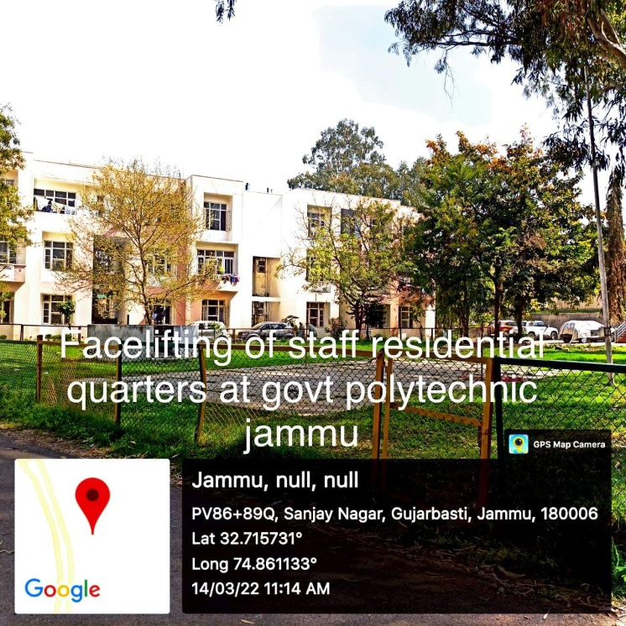 | Sr. No. | 17
 | Name of the  Work with location | Repair/Renovation/Face lifting of Staff Residential Quarters at Govt Polytechnic Jammu
 | Department//  Organisation | Skill Development Department (Directorate of Skill Development)
 | Executing Agency | PWD (R&B)
 | Block/District | Jammu
 | AA Cost (Rs. In lakh) | 10.00
 | Total cost of completion / Expdt incurred ending 3/2022 | 3.93
 | Date of start (Month/year) | Jul-21
 | Date of completion (Month/year) | Oct-21
 | No. of beneficiary | 20

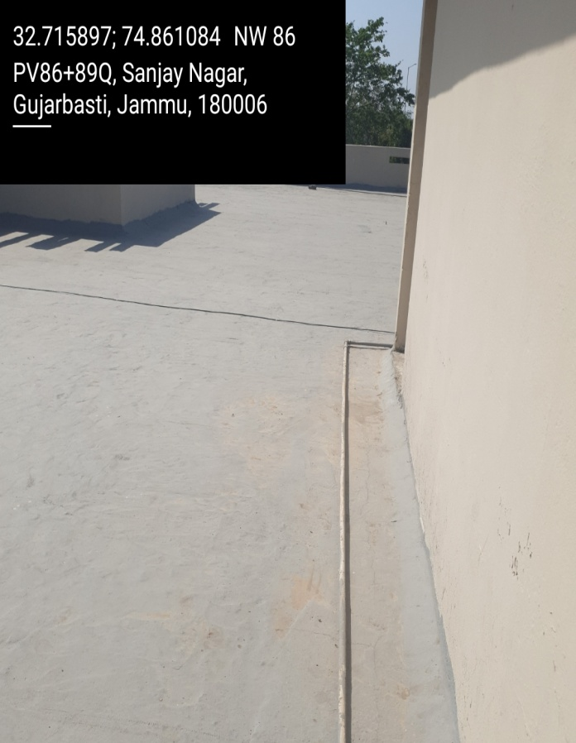 | Sr. No. | 18
 | Name of the  Work with location | Repair / Renovation of DSD Office Jammu (including Flooring, Bathrooms, Roof tiling, Paint etc.)
 | Department//  Organisation | Skill Development Department (Directorate of Skill Development)
 | Executing Agency | PWD (R&B)
 | Block/District | Jammu
 | AA Cost (Rs. In lakh) | 15.00
 | Total cost of completion / Expdt incurred ending 3/2022 | 7.42
 | Date of start (Month/year) | Jul-21
 | Date of completion (Month/year) | Oct-21
 | No. of beneficiary | 45

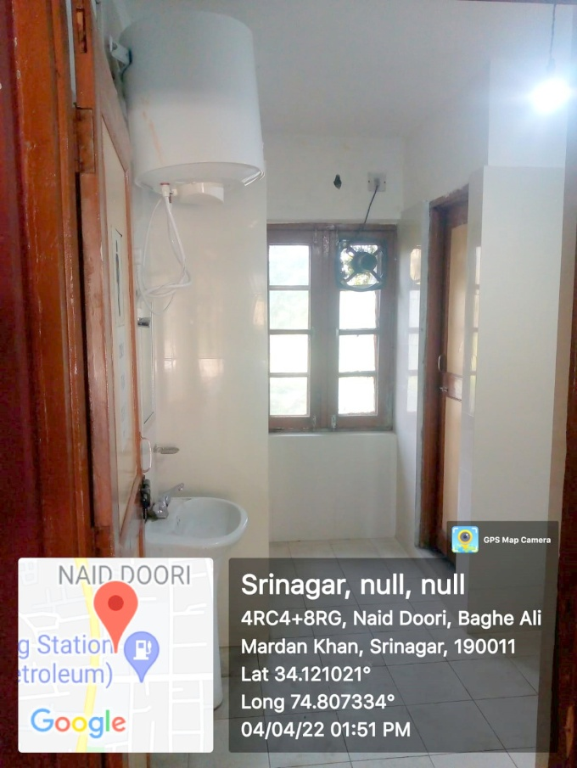 | Sr. No. | 19
 | Name of the  Work with location | Repair/Renovation of Bathrooms at CDI (Craft Development Institute) Srinagar
 | Department//  Organisation | Skill Development Department (Directorate of Skill Development)
 | Executing Agency | PWD (R&B)
 | Block/District | Srinagar
 | AA Cost (Rs. In lakh) | 4.31
 | Total cost of completion / Expdt incurred ending 3/2022 | 2.36
 | Date of start (Month/year) | Jul-21
 | Date of completion (Month/year) | Oct-21
 | No. of beneficiary | 20

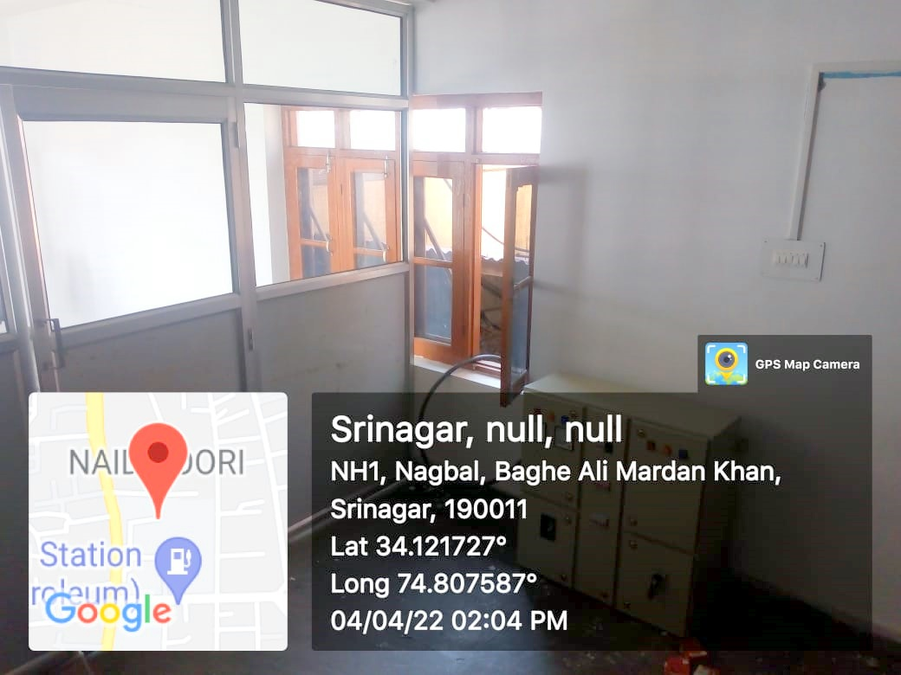 | Sr. No. | 20
 | Name of the  Work with location | Repair/Renovation of Hostel at CDI (Craft Development Institute) Srinagar
 | Department//  Organisation | Skill Development Department (Directorate of Skill Development)
 | Executing Agency | PWD (R&B)
 | Block/District | Srinagar
 | AA Cost (Rs. In lakh) | 14.18
 | Total cost of completion / Expdt incurred ending 3/2022 | 7.51
 | Date of start (Month/year) | Jul-21
 | Date of completion (Month/year) | Mar-22
 | No. of beneficiary | 20

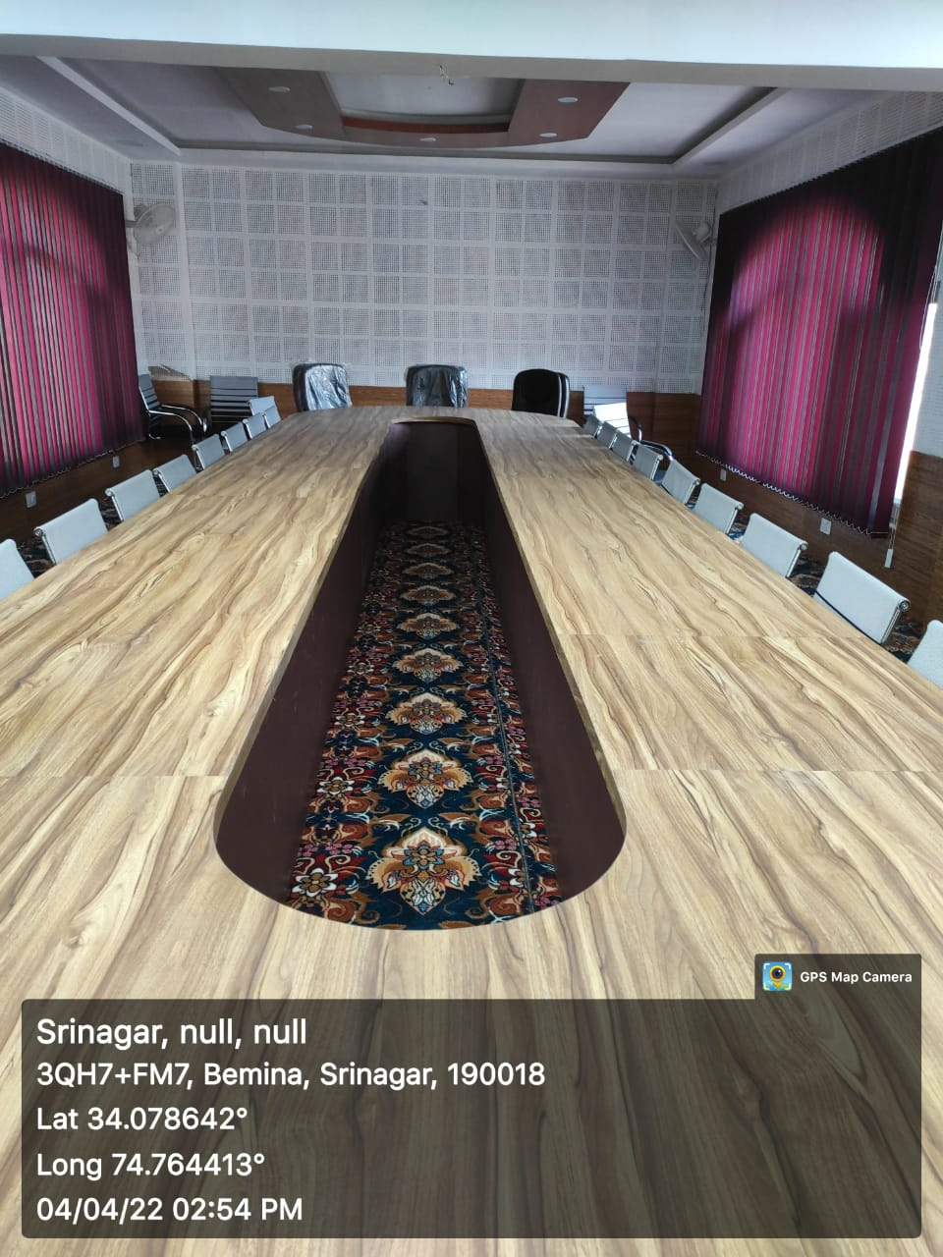 | Sr. No. | 21
 | Name of the  Work with location | Establishment of Conference Hall at Directorate of Technical Education, Srinagar.
 | Department//  Organisation | Skill Development Department (Directorate of Skill Development)
 | Executing Agency | PWD (R&B)
 | Block/District | Srinagar
 | AA Cost (Rs. In lakh) | 16.58
 | Total cost of completion / Expdt incurred ending 3/2022 | 12.44
 | Date of start (Month/year) | Mar-21
 | Date of completion (Month/year) | Mar-22
 | No. of beneficiary | 45

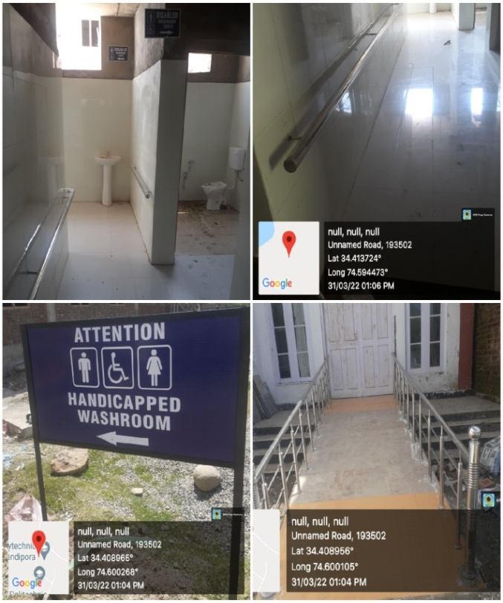 | Sr. No. | 22
 | Name of the  Work with location | Constr of PWD bathroom (M/F) at GP Bandipore
 | Department//  Organisation | Skill Development Department (Directorate of Skill Development)
 | Executing Agency | JKPCC
 | Block/District | Bandipore
 | AA Cost (Rs. In lakh) | 1.35
 | Total cost of completion / Expdt incurred ending 3/2022 | 1.02
 | Date of start (Month/year) | Feb-22
 | Date of completion (Month/year) | Mar-22
 | No. of beneficiary | 06

