ITI Sector

FORMAT –“A”
Abstract of works projects physically completed under UT Capex Budget, Loan, Loan, CSS& PMDP during 2021-22
(Rs. In lakh)
Sr. No. | Source of funds | Total No. of works Physically completed during 2021-22 | Total AA cost | Total cost of completion/ expenditure
 | Capex Regular | 28 | 649.50 | 509.05
 | Loan Schemes | 0 | 0 | 0
 | CSS | 0 | 0 | 0
 | PMDP/Others | 0 | 0 | 0
 | Total: | 28 | 649.50 | 509.05

Format – “C”
Geo tagged Photographs of the work (JPG Format with details)
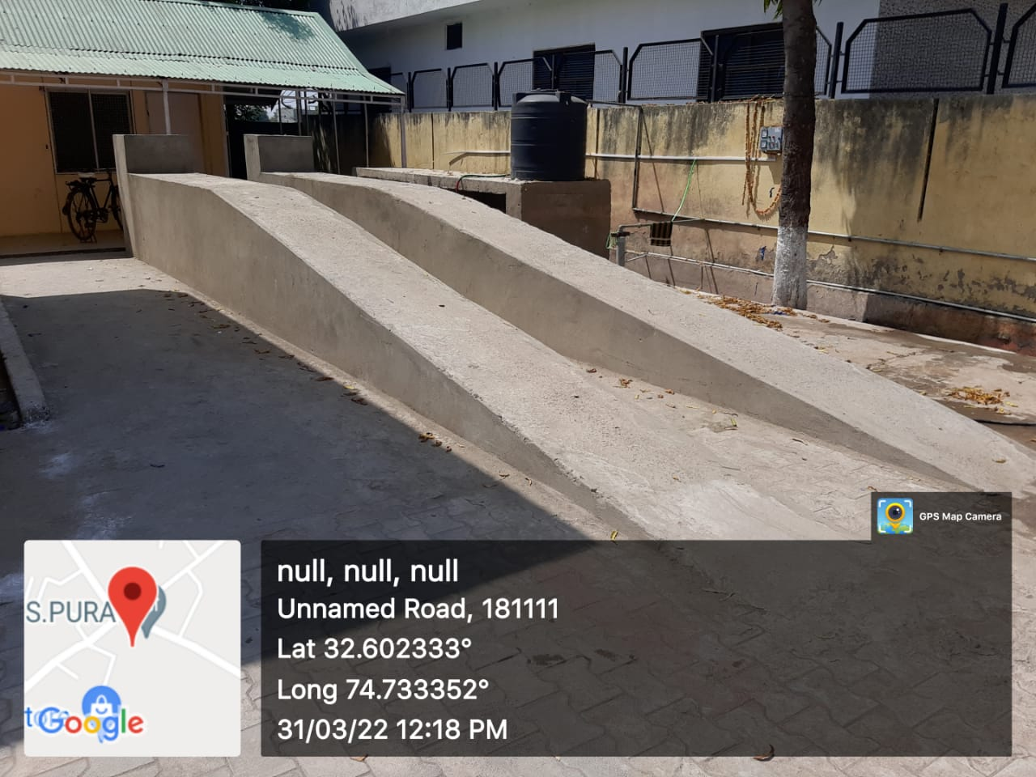 | Sr. No. | 01
 | Name of the  Work with location | Construction of W/ shop for Motor Mechanic (MMV) / Plumber Trade & auto mobile service Station at IT R.S.Pora
 | Department//  Organisation | Skill Development Department (Directorate of Skill Development)
 | Executing Agency | PWD (R&B)
 | Block/District | Jammu
 | AA Cost (Rs. In lakh) | 93.30
 | Total cost of completion/ Expdt incurred ending 3/2022 | 92.78
 | Date of start (Month/year) | Jul-16
 | Date of completion (Month/year) | Mar-22
 | No. of beneficiary | 100 trainees
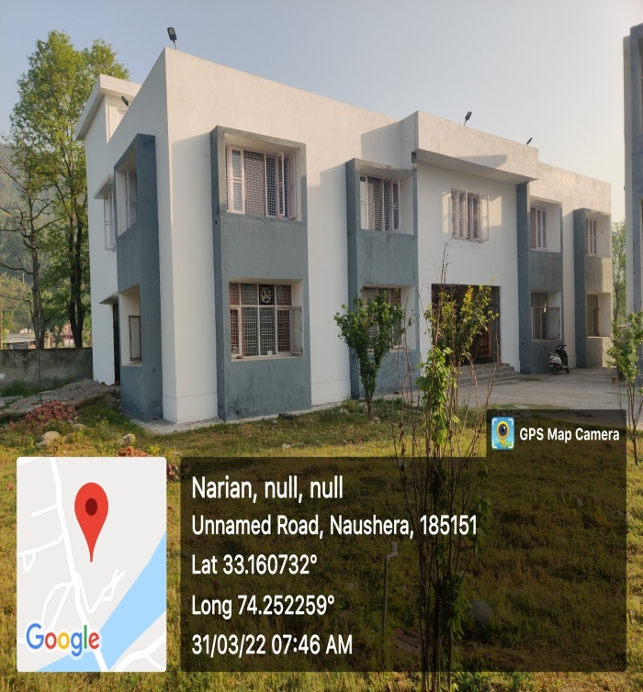 | Sr. No. | 02
 | Name of the  Work with location | Construction of first floor to ITI building at ITI Nowshera
 | Department//  Organisation | Skill Development Department (Directorate of Skill Development)
 | Executing Agency | PWD (R&B)
 | Block/District | Jammu
 | AA Cost (Rs. In lakh) | 99.90
 | Total cost of completion/ Expdt incurred ending 3/2022 | 98.15
 | Date of start (Month/year) | Sep-19
 | Date of completion (Month/year) | Mar-22
 | No. of beneficiary | 150
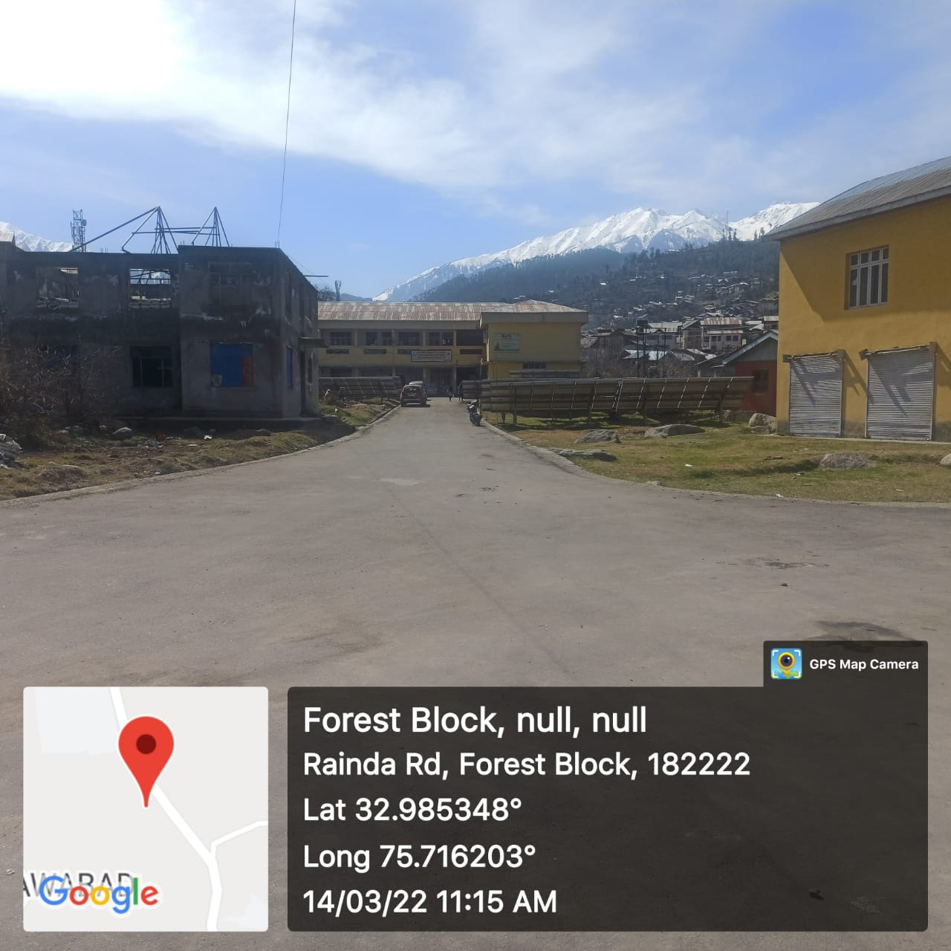 | Sr. No. | 03
 | Name of the  Work with location | Construction of approach road from Main Gate at ITI Bhaderwah
 | Department//  Organisation | Skill Development Department (Directorate of Skill Development)
 | Executing Agency | PWD (R&B)
 | Block/District | Doda
 | AA Cost (Rs. In lakh) | 15.16
 | Total cost of completion/ Expdt incurred ending 3/2022 | 15.00
 | Date of start (Month/year) | Mar-20
 | Date of completion (Month/year) | Sep-21
 | No. of beneficiary | 400
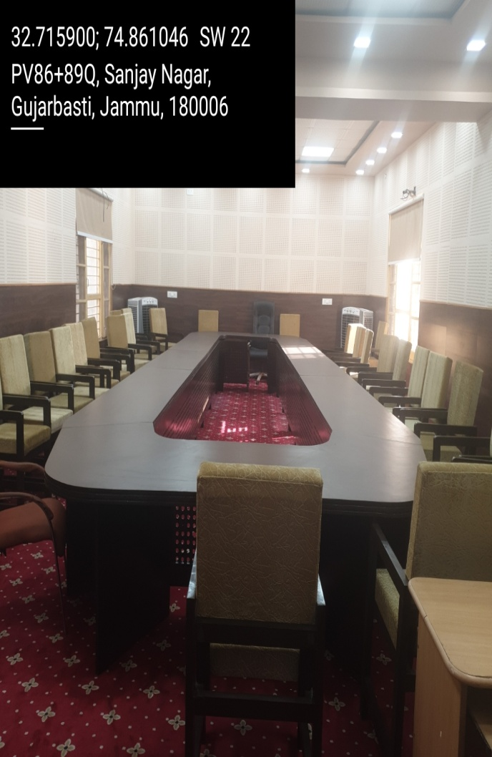 | Sr. No. | 04
 | Name of the  Work with location | Establishment of Conference Hall at Directorate of Technical Education, Jammu
 | Department//  Organisation | Skill Development Department (Directorate of Skill Development)
 | Executing Agency | JKI
 | Block/District | Jammu
 | AA Cost (Rs. In lakh) | 14.51
 | Total cost of completion/ Expdt incurred ending 3/2022 | 6.00
 | Date of start (Month/year) | Oct-19
 | Date of completion (Month/year) | Dec-21
 | No. of beneficiary | 50
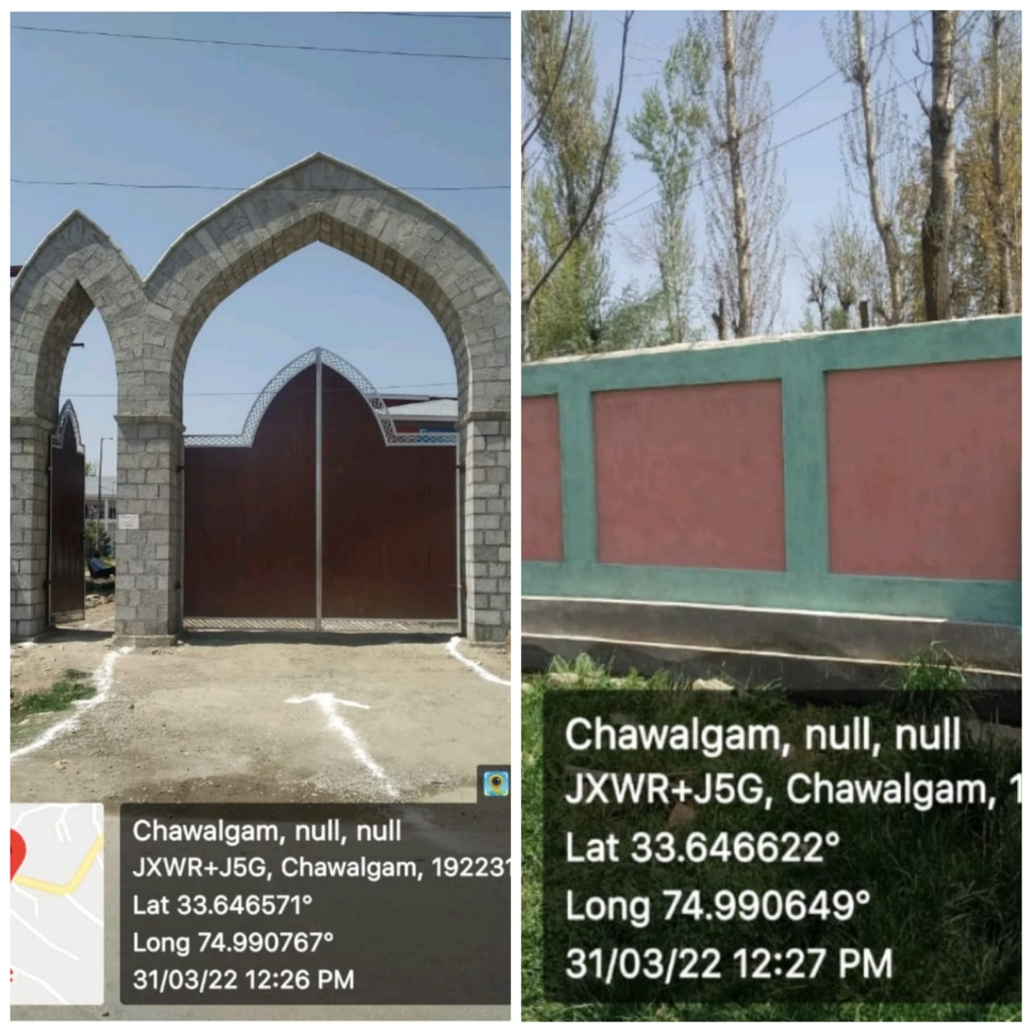 | Sr. No. | 05
 | Name of the  Work with location | Construction of Boundary Wall and Main Gate of Devry Stones at Govt. ITI Kulgam
 | Department//  Organisation | Skill Development Department (Directorate of Skill Development)
 | Executing Agency | J&K Housing Board
 | Block/District | Kulgam
 | AA Cost (Rs. In lakh) | 31.57
 | Total cost of completion/ Expdt incurred ending 3/2022 | 31.20
 | Date of start (Month/year) | Jun-20
 | Date of completion (Month/year) | Mar-22
 | No. of beneficiary | 400
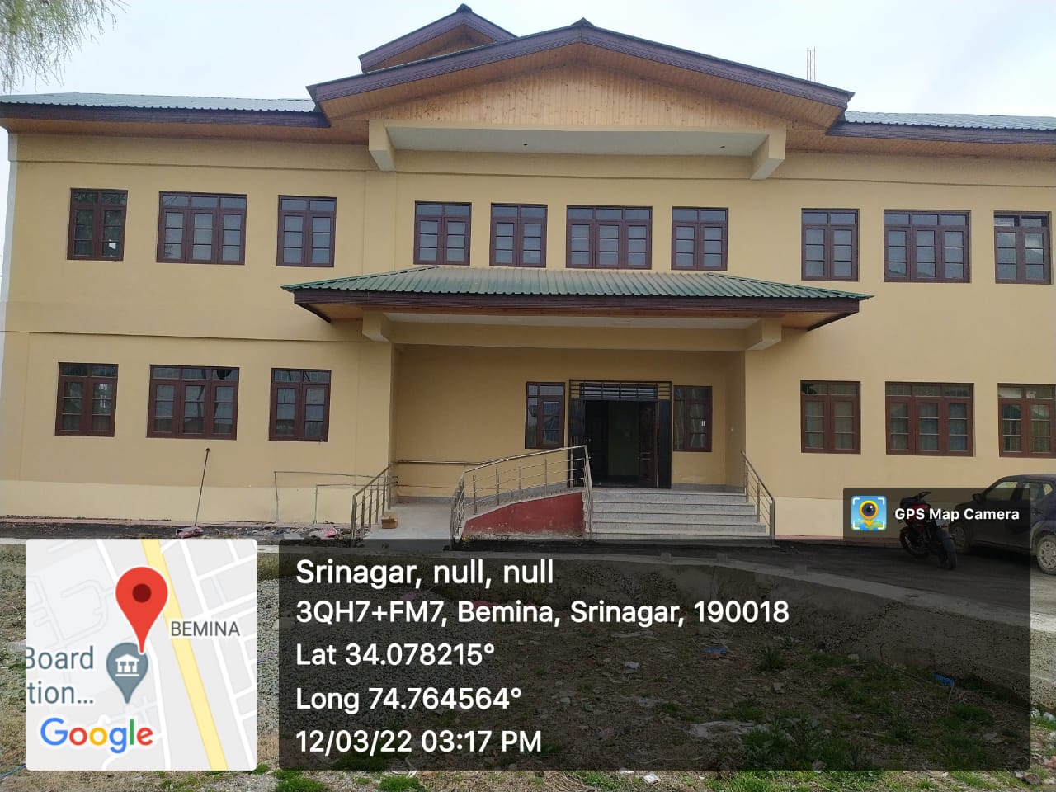 | Sr. No. | 06
 | Name of the  Work with location | Construction of workshop block at Women ITI, Phase-II Bemina
 | Department//  Organisation | Skill Development Department (Directorate of Skill Development)
 | Executing Agency | PWD(R&B)
 | Block/District | Srinagar
 | AA Cost (Rs. In lakh) | 82.58
 | Total cost of completion/ Expdt incurred ending 3/2022 | 66.90
 | Date of start (Month/year) | Jul-20
 | Date of completion (Month/year) | Jun-21
 | No. of beneficiary | 275
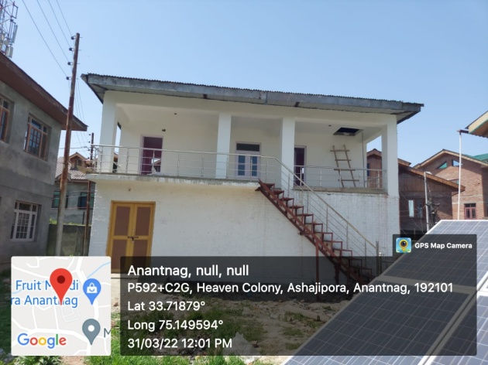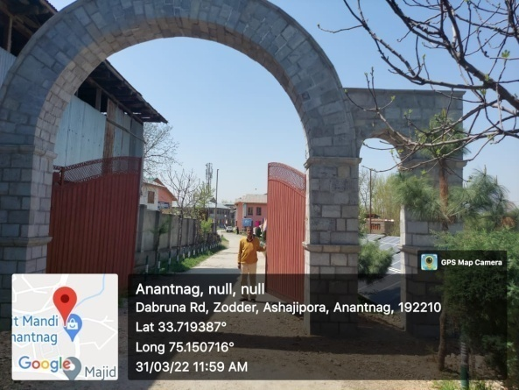 | Sr. No. | 07
 | Name of the  Work with location | Construction of Chowkidar Qtrs and Main gate with Devri Stones at Govt ITI Anantnag
 | Department//  Organisation | Skill Development Department (Directorate of Skill Development)
 | Executing Agency | PWD(R&B)
 | Block/District | Anantnag
 | AA Cost (Rs. In lakh) | 23.91
 | Total cost of completion/ Expdt incurred ending 3/2022 | 17.00
 | Date of start (Month/year) | Sep-21
 | Date of completion (Month/year) | Mar-22
 | No. of beneficiary | 800 trainees
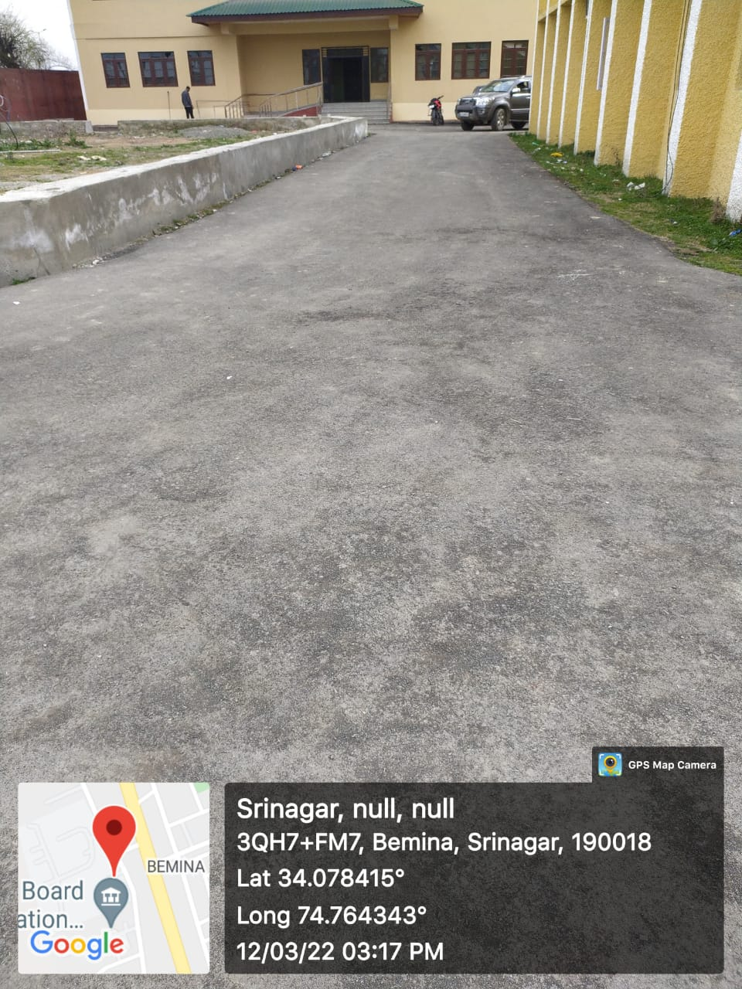 | Sr. No. | 08
 | Name of the  Work with location | Macdamization of Internal Roads at Women ITI Bemina
 | Department//  Organisation | Skill Development Department (Directorate of Skill Development)
 | Executing Agency | PWD(R&B)
 | Block/District | Srinagar
 | AA Cost (Rs. In lakh) | 10.52
 | Total cost of completion/ Expdt incurred ending 3/2022 | 7.80
 | Date of start (Month/year) | May-21
 | Date of completion (Month/year) | Aug-21
 | No. of beneficiary | 300
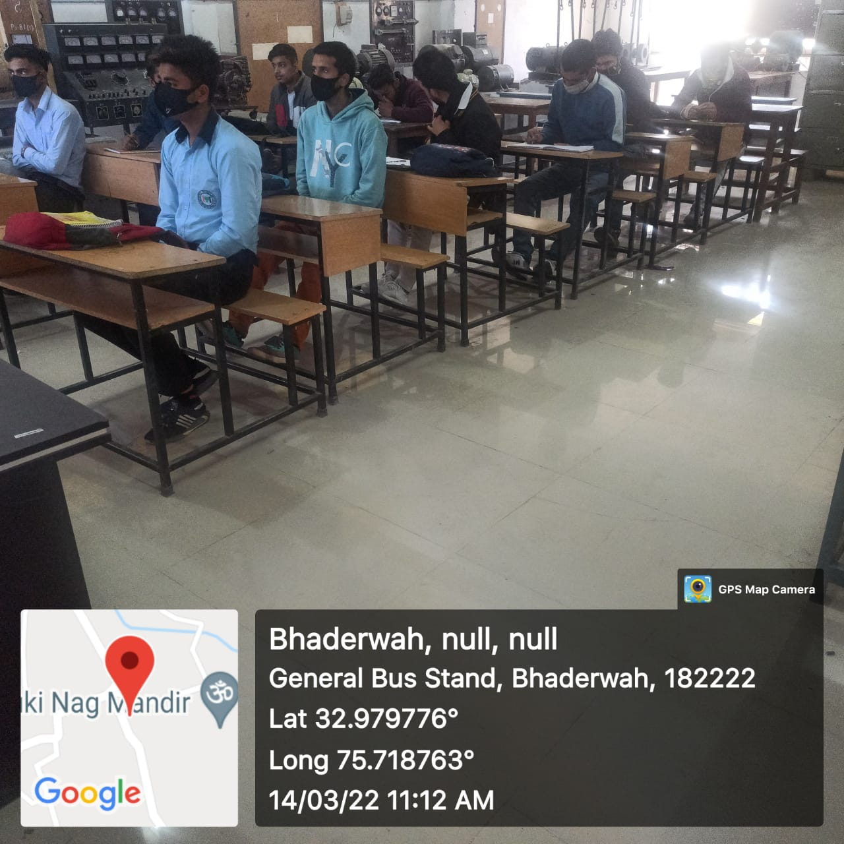 | Sr. No. | 09
 | Name of the  Work with location | Laying of tiles in various trades Buildings at ITI Bhaderwah
 | Department//  Organisation | Skill Development Department (Directorate of Skill Development)
 | Executing Agency | PWD(R&B)
 | Block/District | Doda
 | AA Cost (Rs. In lakh) | 12.00
 | Total cost of completion/ Expdt incurred ending 3/2022 | 6.59
 | Date of start (Month/year) | Jun-21
 | Date of completion (Month/year) | Aug-21
 | No. of beneficiary | 250
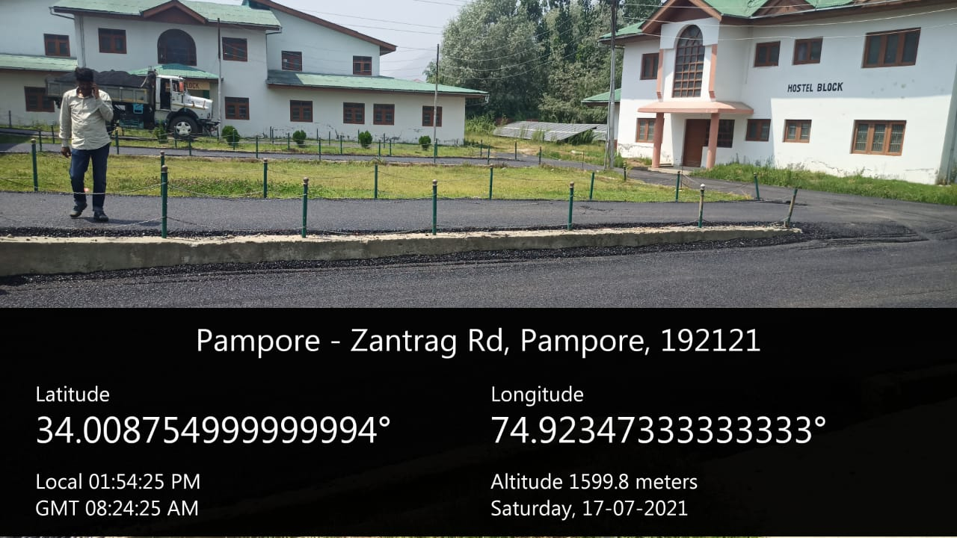 | Sr. No. | 10
 | Name of the  Work with location | Macdamisation of interior roads at Govt. ITI Pampore
 | Department//  Organisation | Skill Development Department (Directorate of Skill Development)
 | Executing Agency | PWD(R&B)
 | Block/District | Pulwama
 | AA Cost (Rs. In lakh) | 20.00
 | Total cost of completion/ Expdt incurred ending 3/2022 | 12.79
 | Date of start (Month/year) | Jun-21
 | Date of completion (Month/year) | Oct-21
 | No. of beneficiary | 300
 | Sr. No. | 11
 | Name of the  Work with location | Construction of workshop block at Women ITI Bemina ( Phase III)
 | Department//  Organisation | Skill Development Department (Directorate of Skill Development)
 | Executing Agency | PWD(R&B)
 | Block/District | Srinagar
 | AA Cost (Rs. In lakh) | 89.62
 | Total cost of completion/ Expdt incurred ending 3/2022 | 60.00
 | Date of start (Month/year) | Jun-21
 | Date of completion (Month/year) | Mar-22
 | No. of beneficiary | 275
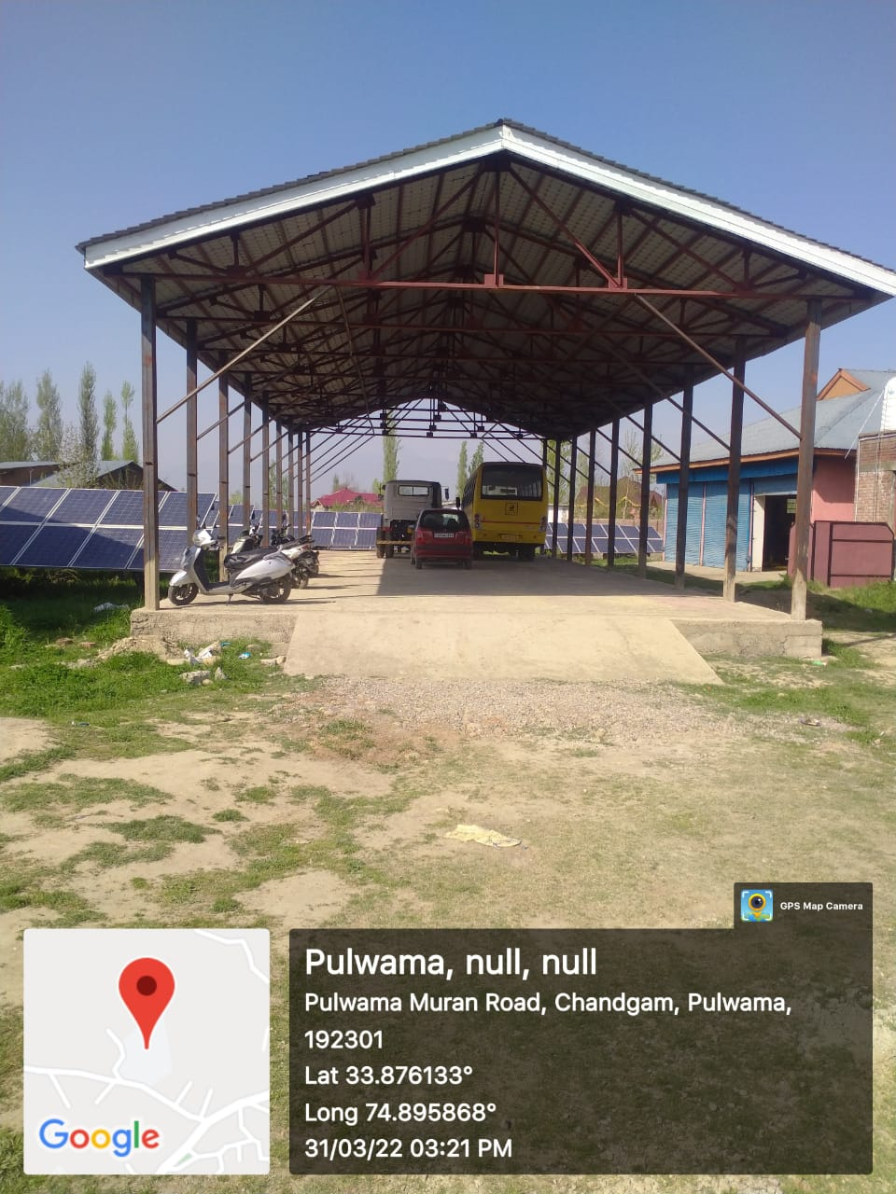 | Sr. No. | 12
 | Name of the  Work with location | construction of Garage and development of parking area at ITI Pulwama
 | Department//  Organisation | Skill Development Department (Directorate of Skill Development)
 | Executing Agency | PWD(R&B)
 | Block/District | Pulwama
 | AA Cost (Rs. In lakhs) | 27.42
 | Total cost of completion/ Expdt incurred ending 3/2022 | 15.00
 | Date of start (Month/year) | Jul-21
 | Date of completion (Month/year) | Dec-21
 | No. of beneficiary | 300
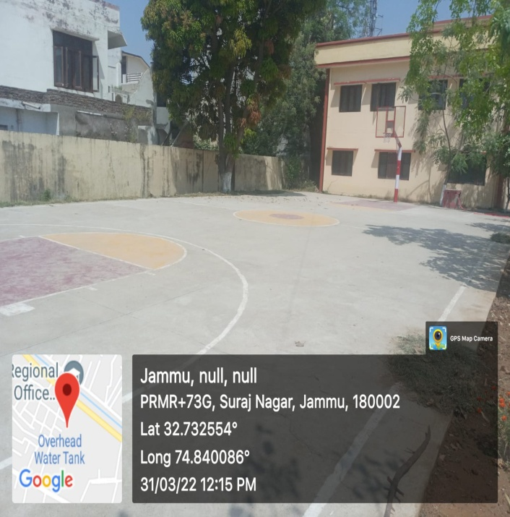 | Sr. No. | 13
 | Name of the  Work with location | Establishment of Basket ball court at Women ITI Jammu
 | Department//  Organisation | Skill Development Department (Directorate of Skill Development)
 | Executing Agency | PWD(R&B)
 | Block/District | Jammu
 | AA Cost (Rs. In lakh) | 10.00
 | Total cost of completion/ Expdt incurred ending 3/2022 | 5.00
 | Date of start (Month/year) | Aug-21
 | Date of completion (Month/year) | Dec-21
 | No. of beneficiary | 164 trainees
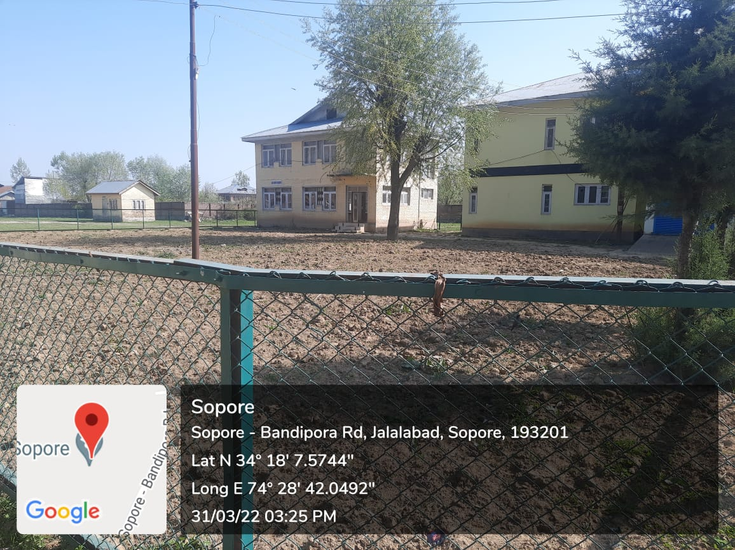 | Sr. No. | 14
 | Name of the  Work with location | Landscape development of ITI Sopore. Construction of fencing around park proposed in front of administration and women's building
 | Department//  Organisation | Skill Development Department (Directorate of Skill Development)
 | Executing Agency | PWD(R&B)
 | Block/District | Baramulla
 | AA Cost (Rs. In lakh) | 3.19
 | Total cost of completion/ Expdt incurred ending 3/2022 | 3.05
 | Date of start (Month/year) | Dec-20
 | Date of completion (Month/year) | Mar-22
 | No. of beneficiary | 300
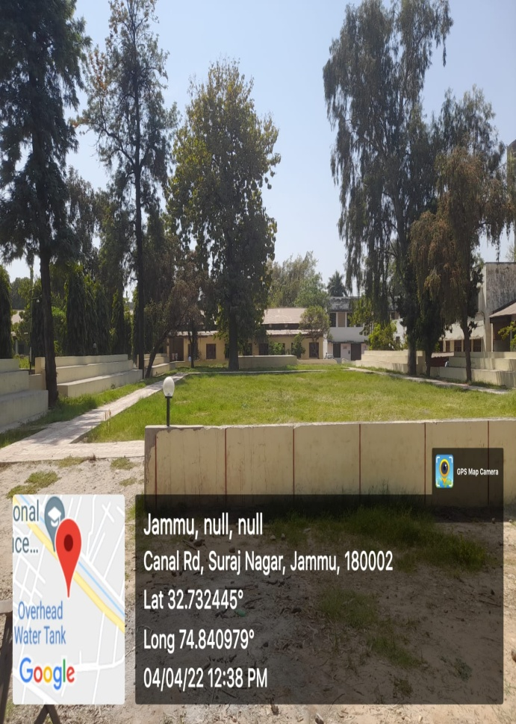 | Sr. No. | 15
 | Name of the  Work with location | Development & Up-gradation of parking area at ITI Jammu
 | Department//  Organisation | Skill Development Department (Directorate of Skill Development)
 | Executing Agency | PWD(R&B)
 | Block/District | Jammu
 | AA Cost (Rs. In lakh) | 10.92
 | Total cost of completion/ Expdt incurred ending 3/2022 | 10.05
 | Date of start (Month/year) | Jul-20
 | Date of completion (Month/year) | Mar-22
 | No. of beneficiary | 900
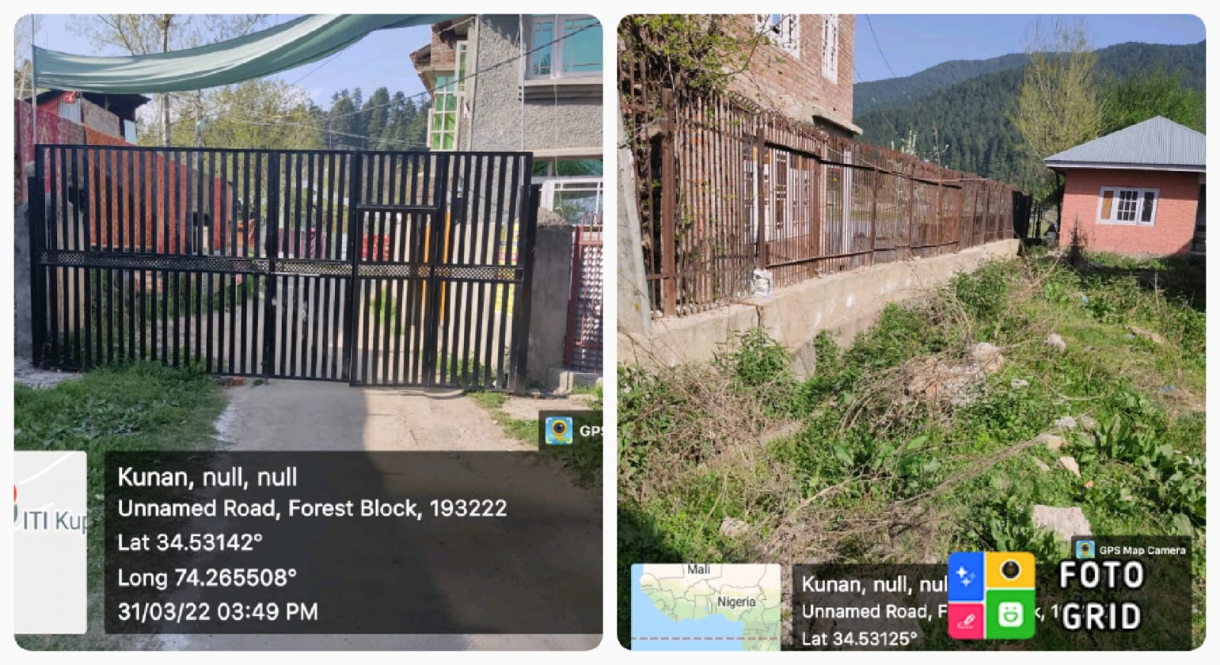 | Sr. No. | 16
 | Name of the  Work with location | Repair of protection wall & Iron fencing grill at ITI Kupwara
 | Department//  Organisation | Skill Development Department (Directorate of Skill Development)
 | Executing Agency | PWD(R&B)
 | Block/District | Kupwara
 | AA Cost (Rs. In lakh) | 6.15
 | Total cost of completion/ Expdt incurred ending 3/2022 | 4.95
 | Date of start (Month/year) | Aug-20
 | Date of completion (Month/year) | Dec-21
 | No. of beneficiary | 250
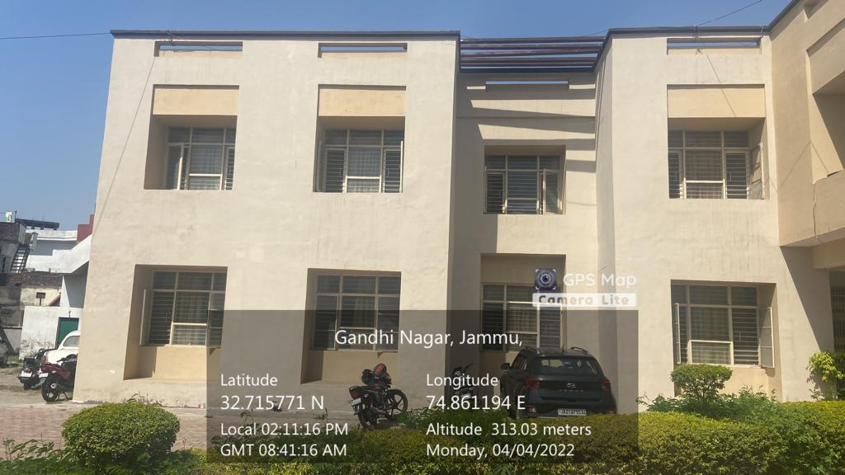 | Sr. No. | 17
 | Name of the  Work with location | White Washing / Face lifting of DSD office at Bikram Chowk Jammu
 | Department//  Organisation | Skill Development Department (Directorate of Skill Development)
 | Executing Agency | PWD(R&B)
 | Block/District | Jammu
 | AA Cost (Rs. In lakh) | 2.00
 | Total cost of completion/ Expdt incurred ending 3/2022 | 0.97
 | Date of start (Month/year) | Oct-20
 | Date of completion (Month/year) | Jun-21
 | No. of beneficiary | 50
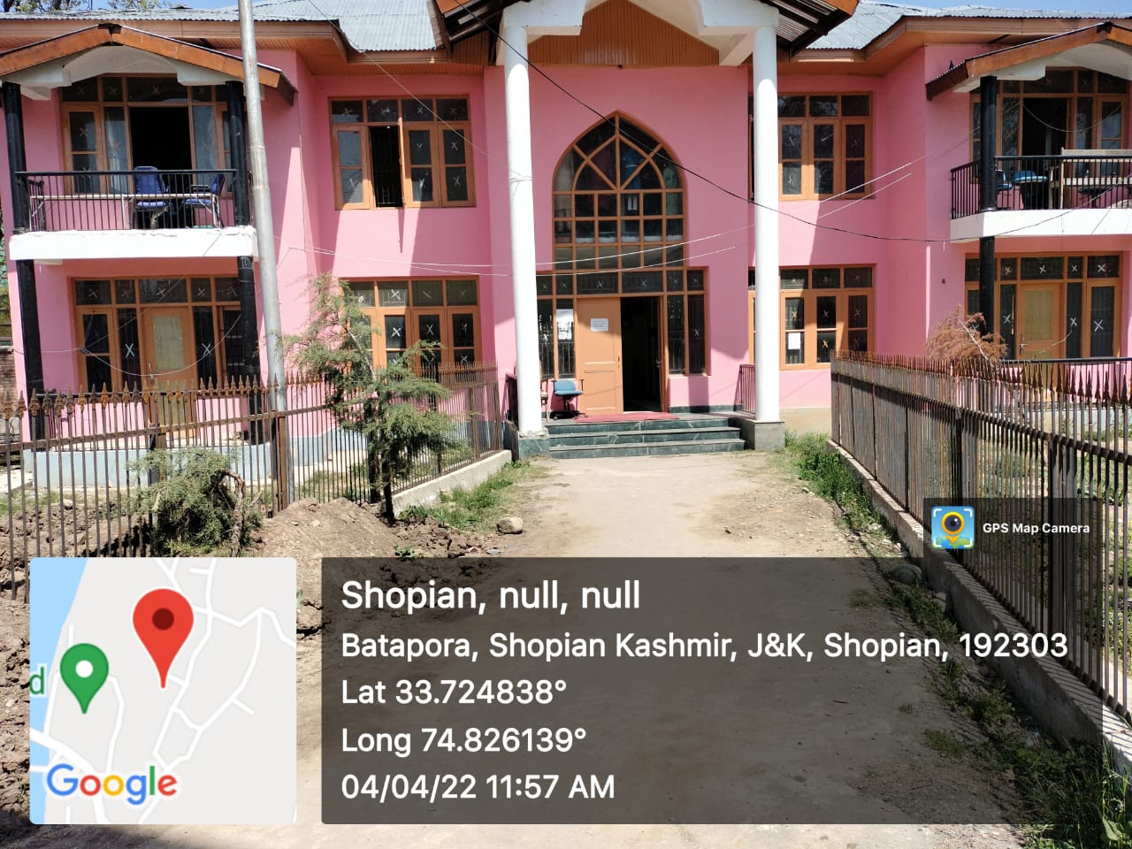 | Sr. No. | 18
 | Name of the  Work with location | Renovation of Hostel Block at ITI building, Shopian
 | Department//  Organisation | Skill Development Department (Directorate of Skill Development)
 | Executing Agency | PWD(R&B)
 | Block/District | Shopian
 | AA Cost (Rs. In lakh) | 8.95
 | Total cost of completion/ Expdt incurred ending 3/2022 | 6.73
 | Date of start (Month/year) | Jun-21
 | Date of completion (Month/year) | Feb-22
 | No. of beneficiary | 200
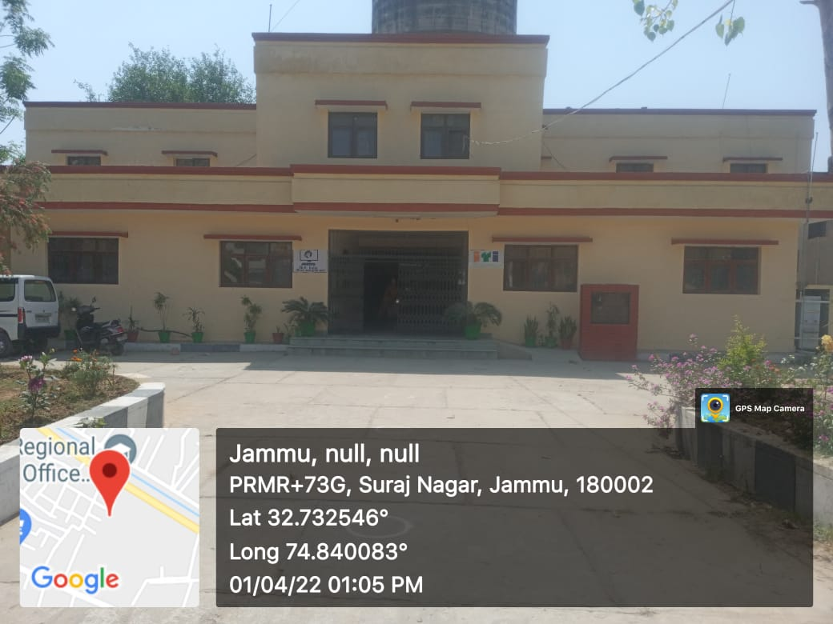 | Sr. No. | 19
 | Name of the  Work with location | Face lfting of Adm Block & Workshop block at Women ITI Jammu
 | Department//  Organisation | Skill Development Department (Directorate of Skill Development)
 | Executing Agency | PWD(R&B)
 | Block/District | Jammu
 | AA Cost (Rs. In lakh) | 11.92
 | Total cost of completion/ Expdt incurred ending 3/2022 | 7.42
 | Date of start (Month/year) | Oct-20
 | Date of completion (Month/year) | Jan-22
 | No. of beneficiary | 220
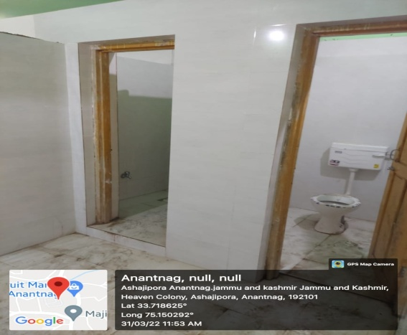 | Sr. No. | 20
 | Name of the  Work with location | Renovation & Construction of Bathrooms (including 1st floor of main block) at ITI Anantnag
 | Department//  Organisation | Skill Development Department (Directorate of Skill Development)
 | Executing Agency | PWD(R&B)
 | Block/District | Anantnag
 | AA Cost (Rs. In lakh) | 10.63
 | Total cost of completion/ Expdt incurred ending 3/2022 | 6.57
 | Date of start (Month/year) | Sep-21
 | Date of completion (Month/year) | Mar-22
 | No. of beneficiary | 800 trainees
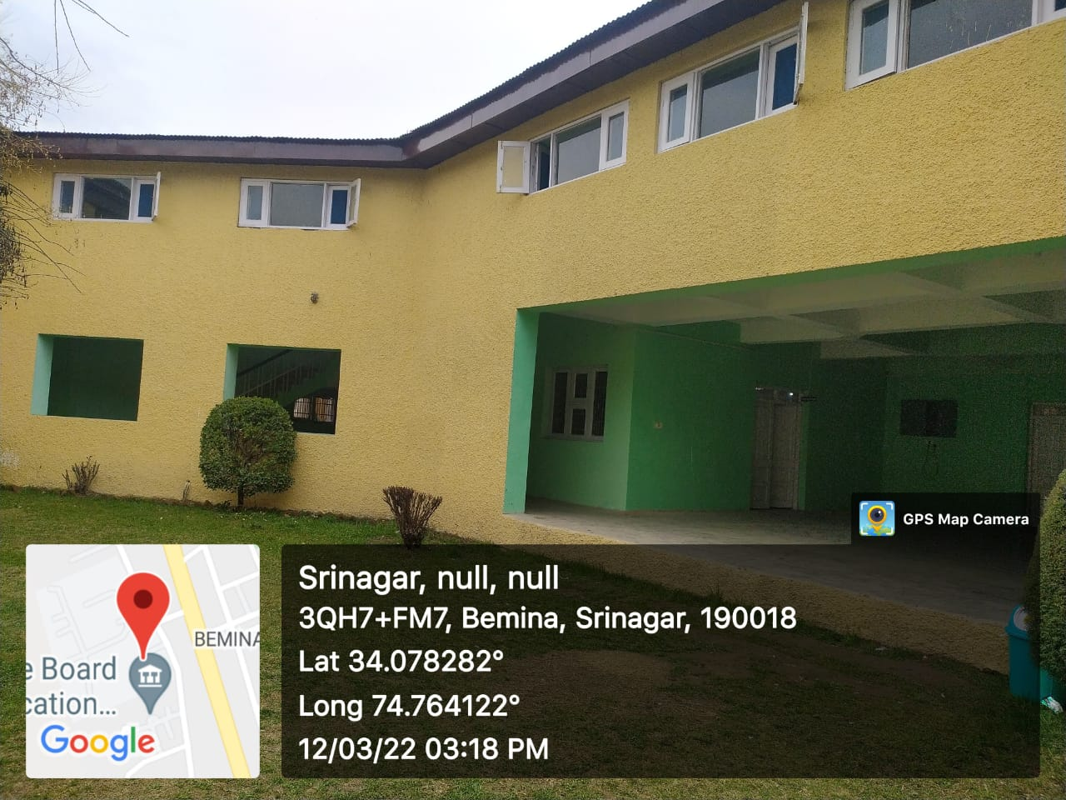 | Sr. No. | 21
 | Name of the  Work with location | Renovation of Ceiling of Stenography Trade & Internal face lifting of Workshops at Women ITI Bemina, Srinagar
 | Department/  Organisation | Skill Development Department (Directorate of Skill Development)
 | Executing Agency | PWD(R&B)
 | Block/District | Srinagar
 | AA Cost (Rs. In lakh) | 12.33
 | Total cost of completion/ Expdt incurred ending 3/2022 | 6.30
 | Date of start (Month/year) | Jun-21
 | Date of completion (Month/year) | Mar-22
 | No. of beneficiary | 300
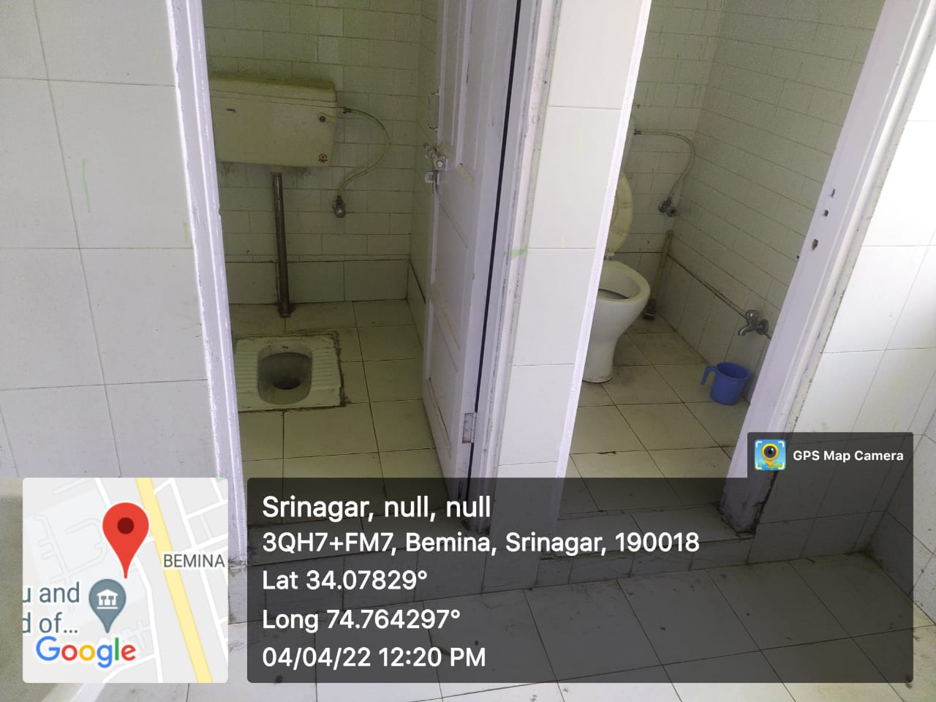 | Sr. No. | 22
 | Name of the  Work with location | Renovation of Washroom & repair/restoration of Sanitary Disposal System at Women ITI Bemina
 | Department//  Organisation | Skill Development Department (Directorate of Skill Development)
 | Executing Agency | PWD(R&B)
 | Block/District | Srinagar
 | AA Cost (Rs. In lakh) | 8.18
 | Total cost of completion/ Expdt incurred ending 3/2022 | 3.58
 | Date of start (Month/year) | Jun-21
 | Date of completion (Month/year) | Mar-22
 | No. of beneficiary | 300
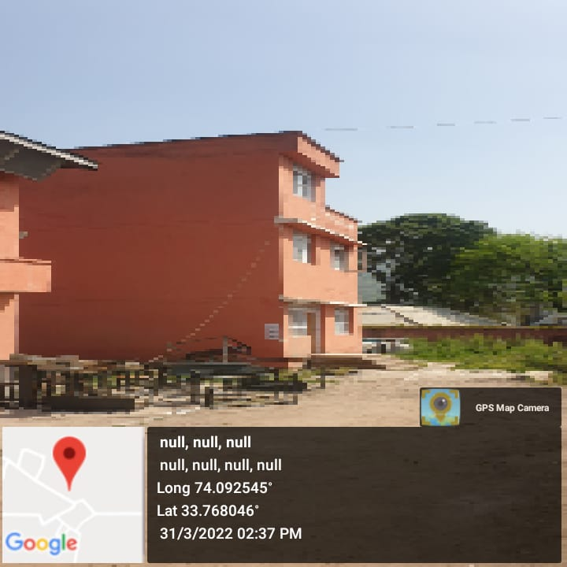 | Sr. No. | 23
 | Name of the  Work with location | Repair / Renovation of ITI complex Poonch
 | Department//  Organisation | Skill Development Department (Directorate of Skill Development)
 | Executing Agency | PWD(R&B)
 | Block/District | Poonch
 | AA Cost (Rs. In lakh) | 11.27
 | Total cost of completion/ Expdt incurred ending 3/2022 | 7.42
 | Date of start (Month/year) | Jun-21
 | Date of completion (Month/year) | Mar-22
 | No. of beneficiary | 400
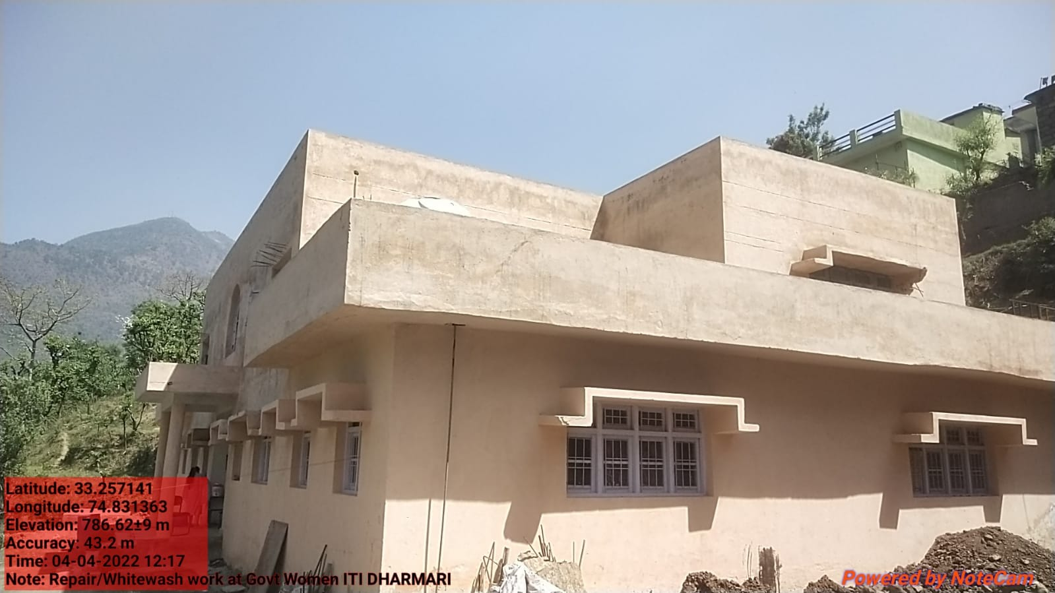 | Sr. No. | 24
 | Name of the  Work with location | Repair/Whitewash of ITI Dharmari
 | Department//  Organisation | Skill Development Department (Directorate of Skill Development)
 | Executing Agency | PWD(R&B)
 | Block/District | Reasi
 | AA Cost (Rs. In lakh) | 1.61
 | Total cost of completion/ Expdt incurred ending 3/2022 | 1.16
 | Date of start (Month/year) | Oct-21
 | Date of completion (Month/year) | Mar-22
 | No. of beneficiary | 150
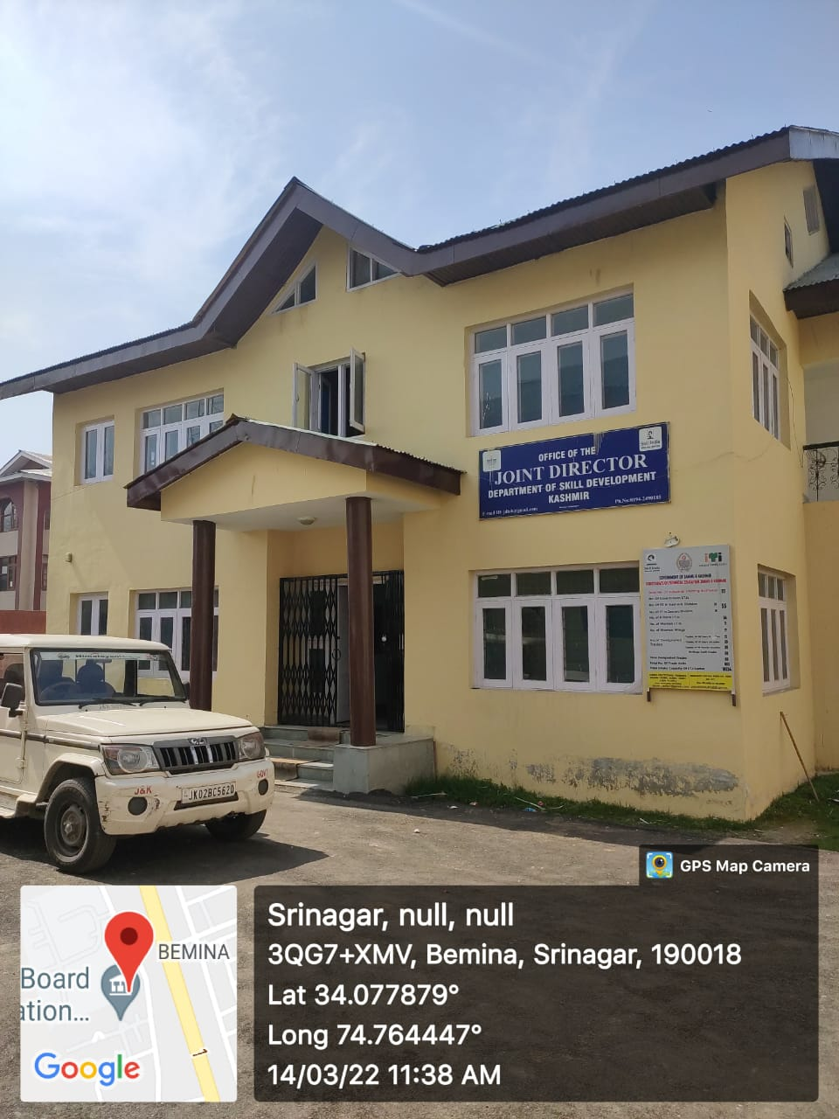 | Sr. No. | 25
 | Name of the  Work with location | Repair/Renovation of Office of Joint Director, Skill Development Kashmir, Bemina
 | Department//  Organisation | Skill Development Department (Directorate of Skill Development)
 | Executing Agency | PWD(R&B)
 | Block/District | Srinagar
 | AA Cost (Rs. In lakh) | 4.84
 | Total cost of completion/ Expdt incurred ending 3/2022 | 2.34
 | Date of start (Month/year) | Oct-21
 | Date of completion (Month/year) | Jan-22
 | No. of beneficiary | 30
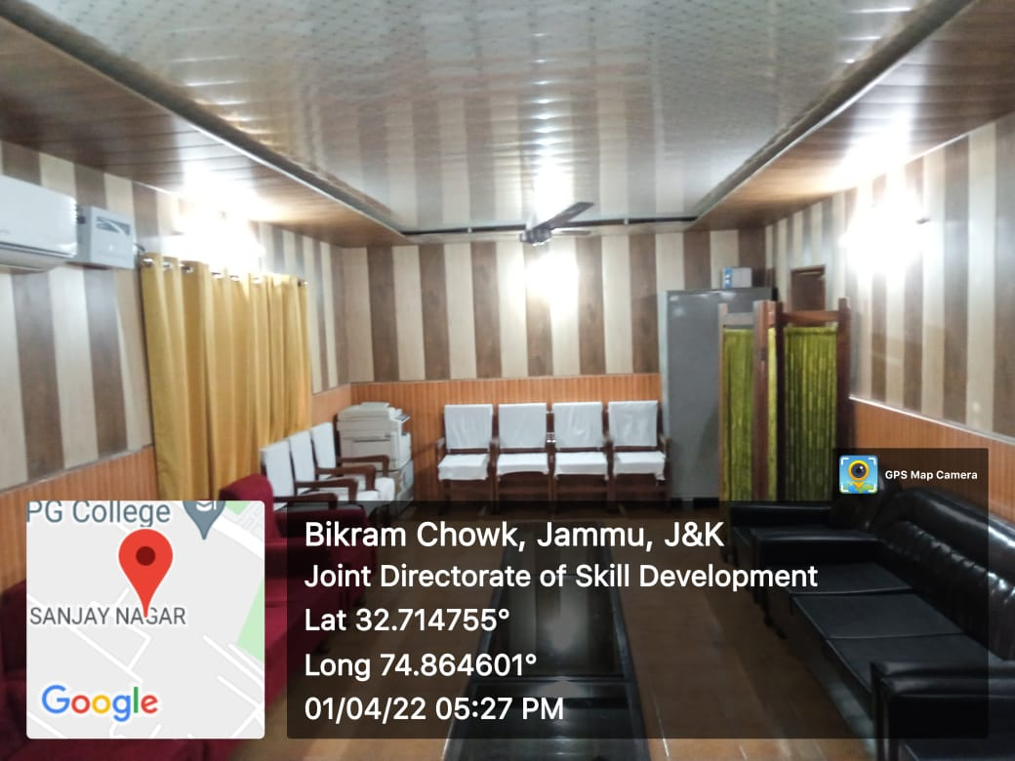 | Sr. No. | 26
 | Name of the  Work with location | Repair/Renovation of Office of Joint Director, Skill Development Jammu
 | Department//  Organisation | Skill Development Department (Directorate of Skill Development)
 | Executing Agency | PWD(R&B)
 | Block/District | Jammu
 | AA Cost (Rs. In lakh) | 4.63
 | Total cost of completion/ Expdt incurred ending 3/2022 | 2.28
 | Date of start (Month/year) | Oct-21
 | Date of completion (Month/year) | Jan-22
 | No. of beneficiary | 30
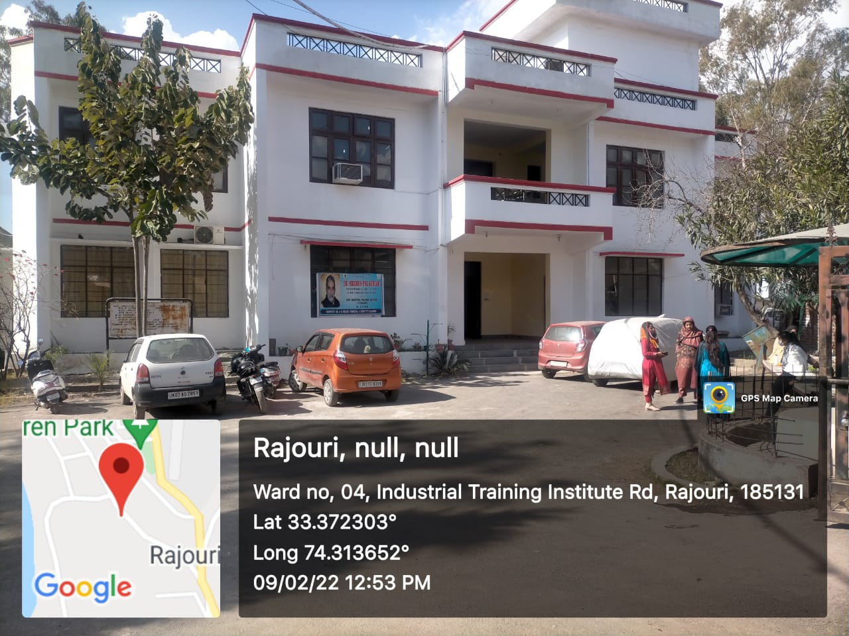 | Sr. No. | 27
 | Name of the  Work with location | Painting / Colour washing of Women Wing block at ITI Rajouri
 | Department//  Organisation | Skill Development Department (Directorate of Skill Development)
 | Executing Agency | PWD(R&B)
 | Block/District | Rajouri
 | AA Cost (Rs. In lakh) | 4.27
 | Total cost of completion/ Expdt incurred ending 3/2022 | 2.14
 | Date of start (Month/year) | Aug-21
 | Date of completion (Month/year) | Mar-22
 | No. of beneficiary | 550
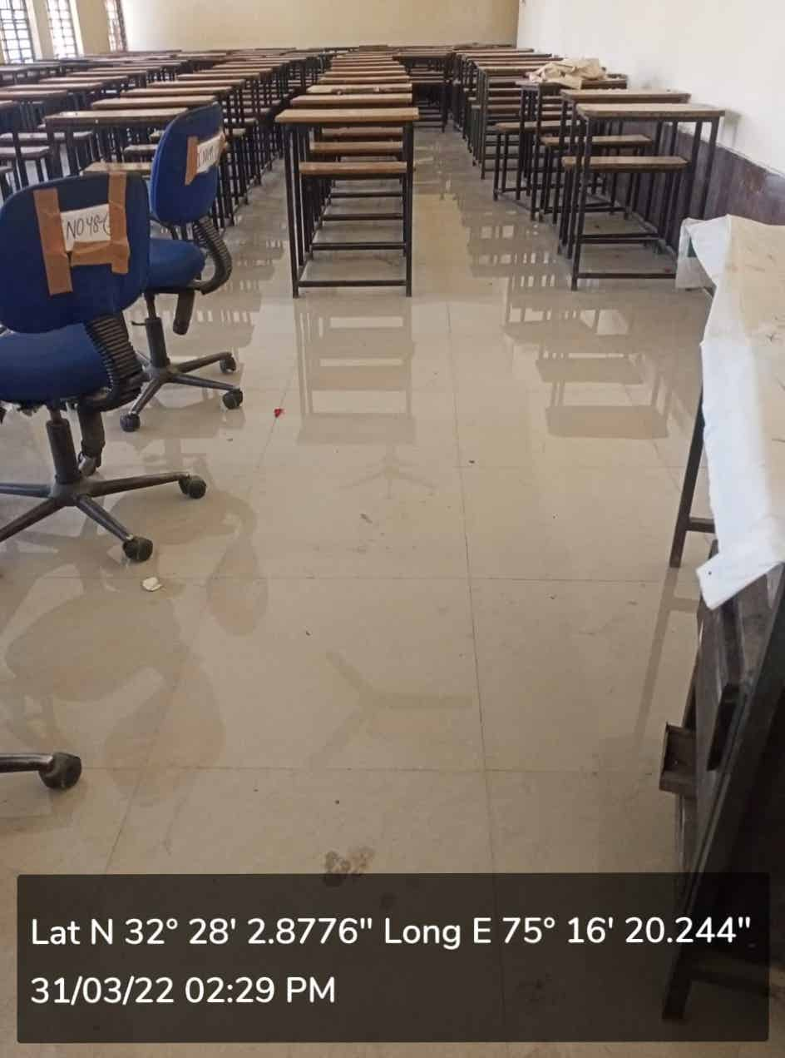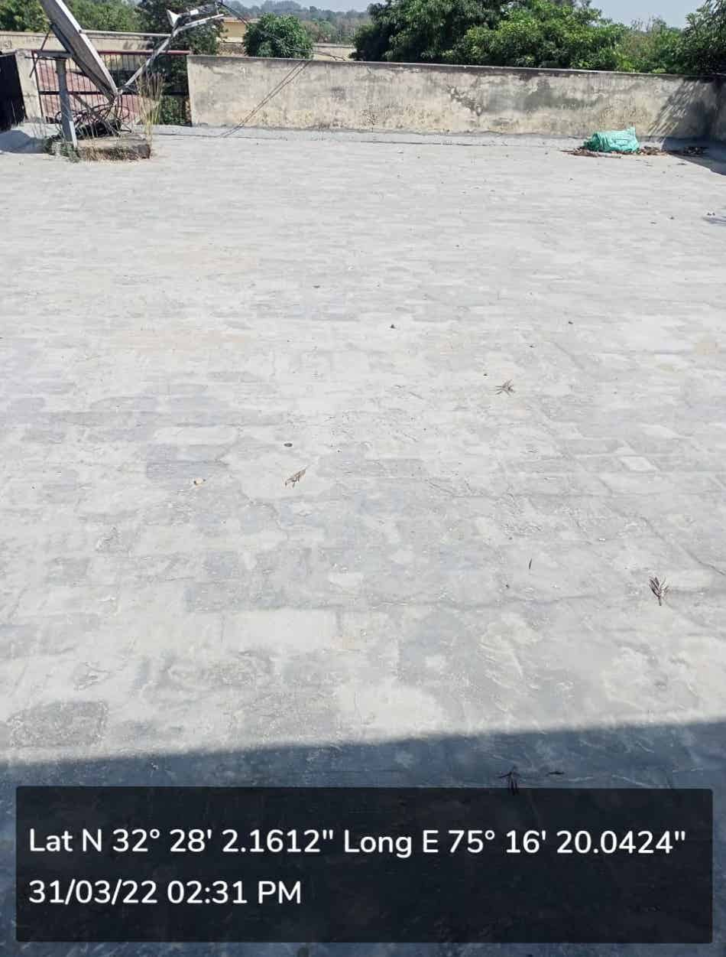 | Sr. No. | 28
 | Name of the  Work with location | Repair/Renovation of main building, Women Building & Hostel Building at ITI Hiranagar
 | Department//  Organisation | Skill Development Department (Directorate of Skill Development)
 | Executing Agency | PWD(R&B)
 | Block/District | Kathua
 | AA Cost (Rs. In lakh) | 18.12
 | Total cost of completion/ Expdt incurred ending 3/2022 | 9.88
 | Date of start (Month/year) | Jul-21
 | Date of completion (Month/year) | Mar-22
 | No. of beneficiary | 500

